Kingdom of Saudi Arabia
Ministry of Higher Education
Imam Abdulrahman Bin Faisal University
College of Computer Sciences & Information Technology

Final Proposal Report

Title: Harnessing Deep Learning to Optimize Emergency Response

A project submitted
in partial fulfillment of the requirements for the degree of
Bachelor of Science in Artificial Intelligence
By:
# | Name | ID | Role
1 | Mohammed Kamal Hadi | 2220004360 | Leader
2 | Abdulrhman Mohammed Alshehri | 2220006250 | Member
3 | Saud Ali Rawdhan | 2220002478 | Member
4 | Ahmad Abdulqader Alakhdar | 2220002324 | Member
5 | Ali Ibrahim Asiri | 2220000306 | Member

Supervised by:
Dr. Mohammad Aftab Alam Khan
Committee Member Names:
……………………….

Date:
………………………..
ACKNOWLEDGEMENT
We want to sincerely thank our supervisor, Dr. Mohammed Aftab, for all the guidance and support he’s given us throughout this project proposal. His valuable insights and expert advice on the technical side really helped shape our research. We also deeply appreciate our co-supervisor, Dr. Atta-ur-Rahman, for his constant encouragement and patience along the way. Their feedback and suggestions have been incredibly helpful and will make a big difference in improving our work.

ABSTRACT
The project "Harnessing Deep Learning to Optimize Emergency Response" is designed to help emergency teams react more quickly and effectively to car accidents. Using advanced AI and computer vision, the system watches live videos from traffic and security cameras to spot accidents as they happen. It then sends detailed alerts to emergency responders, including the exact location of the crash.
By using powerful AI models like YOLO and convolutional neural networks, the system identifies collisions in real time, cutting down response times and improving outcomes. Beyond saving lives, it also helps ease traffic jams around accident sites, working toward the goal of safer, smarter cities. By automating accident detection and reducing the chance of human error, this project aims to make public safety and emergency coordination more reliable and efficient.
Table of Contents
Chapter 1: Introduction 11
1.1 Introduction 11
1.2 Problem Statement 11
1.3 Motivation 12
1.4 Justification 12
1.5 Aims & Objectives 12
1.6 Scope / Limitation of the Study 12
1.7 Social, Professional, Legal, and Ethical Implications 13
1.8 Project Organization 13
Chapter 2: Background and Literature Review 15
2.1 Introduction 15
2.2 Literature Review 15
Chapter 3: Software Project Management Plans (SPMP) 28
3.1 Project Overview 28
3.1.1 Purpose, Scope, and Objectives 28
3.1.2 Assumptions, Constraints and Risks 29
3.1.3 Project Deliverables 30
3.1.4 Schedule and Budget Summary 31
3.1.5 Evolution of the Plan 32
3.1.6 References 33
3.1.7 Definitions and Acronyms 34
3.1.8 Document Structure 35
3.2 Project Organization 35
3.2.1 External Interfaces 36
3.2.2 Internal Structure 36
3.2.3 Roles and Responsibilities 37
3.3 Managerial Process Plans 38
3.3.1 Startup Plan 38
3.3.2 Work Plan 39
3.3.3 Project Tracking Plan 43
3.3.4 Risk Management Plan 45
3.3.5 Project Closeout Plan 45
3.4 Technical Process Plans 46
3.4.1 Process Model 46
3.4.2 Methods, Tools, and Techniques 48
3.4.3 Infrastructure 48
3.4.4 Product Acceptance 49
3.5 Supporting Process Plans 49
3.6 Additional Plans 50
3.6.1 Data Privacy and Security 50
3.6.2 Documentation and User Operation 50
3.6.3 Maintenance and Updates 50
3.6.4 Deployment Considerations 50
3.6.5 Ethical and Legal Considerations 50
Chapter 4: Software Requirements Specification (SRS) 51
4.1 Introduction 51
4.1.1 Purpose 51
4.1.2 Scope 51
4.1.3 Definitions, Acronyms, and Abbreviations 51
4.1.4 References 52
4.2 Overall description 53
4.2.1 Product perspective 53
4.2.2 Product functions 53
4.3 Specific requirements 56
4.3.1 External interface requirements 56
Chapter 5: Software Design Specification (SDS) 65
5.1 Introduction 65
5.1.1 Purpose 65
5.1.2 Scope 65
5.1.3 Definitions, Acronyms, and Abbreviations 65
5.1.4 References 66
5.2 System overview 68
5.2.1 System Functionality 68
5.2.2 User Functionality 68
5.3 Design Considerations 70
5.3.1 Assumptions and Dependencies 70
5.3.2 General Constraints 71
5.4 User Interface Design 74
5.4.1 Overview of User Interface 74
5.4.2 Interface Design Rules 74
5.4.3 Screen Images 75
5.4.4 Screen Objects and Actions 80
5.4.5 Other Interfaces 82
5.5 System Architecture 84
5.5.1 Architectural Design Approach 84
5.5.2 Architectural Design 85
5.5.3 Subsystem Architecture 87
5.6 Data Design 91
5.6.1 Data Description 91
5.6.2 Data Dictionary 91
5.6.3 Database Description 95
5.7 Component Design 97
5.7.1 Detection Engine Component 97
5.7.2 Event Orchestrator Component 97
5.7.3 Assignment Engine Component 97
5.7.4 Notification Component 98
5.7.5 Repository Layer (Data Access Component) 98
5.8 Detailed System Design 99
5.8.1 Classification, Definition and Responsibilities 99
5.8.2 Composition 100
5.8.3 Uses/Interactions 100
5.8.4 Resources 101
5.8.5 Processing 102
5.8.6 Interface/Exports 105
5.8.7 Detailed Subsystem Design 106
5.9 Other Design Features 107
5.10 Requirements Traceability Matrix 108
References 109

Table of Tables
Table 1: List of Abbreviations. 10
Table 2: Literature Review Summary. 27
Table 3: Key projects risks 30
Table 4: Project Deliverables 31
Table 5: Schedule summary 32
Table 6: Acronyms 35
Table 7: Roles and Responsibilities 37
Table 8: Human Resources and Phase Duration 39
Table 9: Required Skills for Project Roles 39
Table 10: Work Breakdown Structure 41
Table 11: Schedule Allocation (First Semester) 43
Table 12: Technical and Informational Resources 43
Table 13: Key Project Metrics 45
Table 14: Risk Management Plan 45
Table 15:The Waterfall Phases 47
Table 16: Used Tools 48
Table 17: The Essential Requirements 49
Table 18: Supporting Process Plans 50
Table 19: Glossary of Acronyms and Abbreviations 52
Table 20: Login Interface 56
Table 21: Admin Dashboard Interface 57
Table 22: Camera Management Interface 58
Table 23: User Management Interface 58
Table 24: Responder Dashboard Interface 61
Table 25: Accident Alert Interface 61
Table 26: Accident Alert Interface 62
Table 27: Glossary of Terms and Acronyms. 66
Table 28: User Interface Controls and Interactions. 82
Table 29: System Data Dictionary. 95
Table 30: Component Definitions and Responsibilities. 100
Table 31: Component Constraints and Conditions. 100
Table 32: Resource Allocation and Concurrency Management. 102
Table 33: Process Specification of Video Acquisition & Detection. 102
Table 34: Process Specification of Emergency Event Management. 103
Table 35: Process Specification of Emergency Units Management. 104
Table 36: Process Specification of Notification & Alerting. 104
Table 37: Process Specification of UI Dashboard. 105
Table 38: Process Specification of Data Management & Storage. 105
Table 39: System Interface Specifications. 106
Table 40: Requirements Traceability Matrix Linking SRS Functional Requirements to SDS System Components 108

Table of Figures
Figure 1: Internal structure 37
Figure 2: Gantt Chart: Project Schedule 44
Figure 3: The Waterfall Model 46
Figure 4: Admin Use Case 55
Figure 5: First Responders Use Case 55
Figure 6: Admin workflow system 59
Figure 7: The Responders Login Flow 60
Figure 8: AI Alert System Flow 63
Figure 9: Secure emergency response login screen with system branding and role-based sign-in. 75
Figure 10: Reset Password Interface. 76
Figure 11: System Administrator Operational Dashboard. 76
Figure 12: Camera Management Interface. 77
Figure 13: User Management Interface. 77
Figure 14: System Audit Log Interface. 78
Figure 15: First Responder Active Incidents Dashboard. 78
Figure 16: First Responder Incident Reports Interface. 79
Figure 17: Accident Details Interface. 79
Figure 18: Physical Entity Relationship Diagram. 95
Figure 19: ERD Mapping Relational Schema. 96
Figure 20: Sequence of Interactions Across Subsystems. 101

List of abbreviations
AI | Artificial Intelligence
YOLO | You Only Look Once (Object Detection Model)
CNN | Convolutional Neural Network
GAN | Generative Adversarial Network
UAV | Unmanned Aerial Vehicle
LSTM | Long Short-Term Memory (Neural Network type)
GPS | Global Positioning System
STP | Software Testing Plan
SPMP | Software Project Management Plan
SRS | Software Requirement Specification
SDS | Software Design Specification
MTT | Motion Temporal Templates (used in motion tracking)
CNN Encoder | Convolutional Neural Network Encoder
ViT | Vision Transformer
BPM | Business Process Management (related to drone incident response)
LLM | Large Language Model
TAD | Traffic Accidents Dataset
TAA | Traffic Accident Anticipation
DeepSORT | Deep Learning-based Sorting Algorithm for tracking multiple objects
Table 1: List of Abbreviations.

Chapter 1: Introduction
This chapter kicks off with a brief introduction to the project, highlighting key details and exploring the scope and limitations of the problem at hand. It also outlines the main causes and reasons behind the issue, along with the goals this project aims to achieve. The chapter wraps up by explaining how the project is structured to guide the reader through what’s coming next.

1.1 Introduction
Our project, Optimizing Emergency Response, is all about helping emergency teams react to car accidents faster and more effectively. The project use advanced computer vision and AI to monitor live video feeds from traffic and security cameras. Whenever our system detects that an accident has happened, it instantly sends an alert to emergency services, no waiting for someone to call it in. These alerts include key details like the location and severity of the accident, giving police, paramedics, and firefighters the head start they need.
At the core of our solution are AI models trained to spot crash patterns and unusual road behavior. Using technologies such as YOLO and convolutional neural networks, our system analyzes footage in real time, recognizing collisions within seconds. Once detected, surrounding authorities are notified immediately so they can act quickly and prepare the right resources.
The benefits go beyond saving lives. Rapid detection helps traffic authorities reroute vehicles to ease congestion around accident scenes, which reduces the risk of secondary crashes and keeps the roads moving. It’s a step toward building safer, smarter cities where technology actively works to protect people.
By removing human errors from accident reporting and delivering precise, timely information, the system empowers first responders to make better decisions under pressure. The result is faster rescues, less chaos, and a more coordinated emergency response.
Optimizing Emergency Response isn’t just a technological upgrade, it’s a vision for how AI can strengthen public safety and make our cities more resilient. We’re showing what’s possible when innovation directly serves the well-being of communities.

1.2 Problem Statement
Every second matters when it comes to responding to car accidents, but emergency teams often lose time because reports come in too slowly or with incomplete details. In many cases, crashes go unreported for several minutes, time that can make a life-or-death difference. Even once help is on the way, traffic congestion and unsafe driving around emergency vehicles can slow responders down further, putting both victims and rescuers at greater risk.
Right now, emergency responses still depend heavily on human calls and eyewitness accounts. That system leaves too much room for delays and errors. Our project tackles this challenge by using AI and computer vision to detect accidents the moment they happen. By analyzing live video feeds in real time, the system can instantly alert emergency teams with accurate information on location and severity, helping them mobilize immediately.

1.3 Motivation
- Help emergency teams spot accidents faster so they can save lives.
- Stop delays by automatically detecting accidents instead of waiting for calls.
- Give clearer, more accurate info to first responders.
- Reduce traffic jams caused by accidents for smoother roads.
- Support Saudi Arabia's Vision 2030 goal of safer roads and smarter cities.
- Use modern AI technology to improve public safety.
- Make emergency response quicker, smarter, and more reliable.

1.4 Justification
This project matters because fast and accurate accident detection can make the difference between life and death. Today, emergency teams usually rely on people calling in accidents, which often leads to delays or missing details. By detecting accidents automatically and sending out alerts right away, responders can act faster and more effectively. The initiative also aligns with Saudi Arabia’s Vision 2030, supporting the country’s goal of building safer, smarter cities through advanced technology. It closes a critical gap in how emergencies are reported and managed, offering a practical solution that benefits both first responders and the public they serve.

1.5 Aims & Objectives
The goal of this project is to create a smart system that can spot car accidents as they happen by using advanced computer vision technology. By detecting accidents in real time, the system will help emergency services respond faster, save lives, and improve overall road safety. It will also deliver precise details about the accident’s location, giving first responders the information they need to prepare effectively before reaching the scene.
To make this possible, the project will build a system that continuously watches live videos from surveillance cameras, analyzes it using powerful deep learning models, and identifies accidents within seconds. Once an accident is detected, alerts will be sent immediately to emergency crews along with key information, while traffic authorities can reroute vehicles to prevent congestion. In doing so, the project aims to boost the efficiency of emergency response and contribute to Saudi Arabia’s Vision 2030 by promoting safer roads and smarter cities.

1.6 Scope / Limitation of the Study
This project aims to develop a smart system that can detect car accidents in real time using video feeds from surveillance cameras. Its focus includes identifying accidents as they happen, sending instant alerts to emergency services, and helping manage traffic flow around the affected area.
There are, however, a few limitations to consider. The system’s performance depends heavily on the availability and clarity of camera footage, which can be influenced by factors like weather, lighting conditions, and camera angles. Privacy and data security regulations may also restrict access to certain video sources. In addition, the detection models might occasionally generate false alarms or miss complex accident situations, and hardware issues could impact reliability.
Lastly, this project is designed mainly for urban traffic settings, so results may differ in rural or less monitored regions.

1.7 Social, Professional, Legal, and Ethical Implications
This project aims to save lives by speeding up emergency response and improving road safety. It quickly detects accidents, protecting drivers, passengers, and pedestrians while giving emergency teams accurate, real-time information to act faster. It also supports smarter city planning through valuable traffic data.
Legally and ethically, the project must protect privacy and secure all video data. It should follow regulations, use technology responsibly, minimize errors, and ensure transparency and accountability to maintain public trust.

1.8 Project Organization
The organization of this project is structured into eight main chapters, each focusing on important aspects of the development and implementation process:

- Chapter 1: Introduction
This chapter provides a clear overview of the project, outlining the problem, its scope, limitations, motivations, and objectives. It also explains why this project is important and how it fits within broader goals like Saudi Arabia’s Vision 2030.
- Chapter 2: Background and Review of Literature
Here, the project examine existing research and technologies related to accident detection, AI, and computer vision, giving context to our approach and highlighting advancements and gaps.
- Chapter 3: Software Project Management Plans (SPMP)
This section details the project’s scope, timeline, deliverables, risks, assumptions, and resource planning to ensure smooth execution.
- Chapter 4: Methodology/Software Requirement Specification (SRS)
This chapter explains the technical approach, including AI models, data requirements, and system functionalities that are necessary to achieve the project’s goals.
- Chapter 5: Software Design Specification (SDS)
Here, the architecture of the system is described in detail, outlining how components like video processing, accident detection algorithms, alert mechanisms, and user interfaces interact.
- Chapter 6: Implementation
This chapter covers the practical development of the system, including training AI models, integrating with hardware, testing for accuracy and reliability, and refining based on results.
- Chapter 7: Software Testing Plan (STP)
This chapter outlines how the system will be tested to ensure it works correctly and reliably. It covers the testing methods for all key components, verifying accuracy, performance, and user experience.
- Chapter 8: Conclusion
The final chapter summarizes the project’s outcomes, key achievements, limitations, and lessons learned. It also suggests areas for future improvements and research.

Chapter 2: Background and Literature Review
This chapter gives an overview of past research on using artificial intelligence and computer vision for real-time accident detection and emergency response. It summarizes the methods used, the datasets and video sources tested, and how each system’s performance was evaluated. The review also points out the main results and limitations found in previous studies. By doing so, it helps identify what has already been achieved, where the gaps remain, and how these insights shape the design of our own accident detection system.

2.1 Introduction
This literature review examines key studies on using artificial intelligence for real-time traffic accident detection and emergency response. The research review explores different techniques, including deep learning, computer vision, and multimodal methods, applied to surveillance footage, sensor data, and emergency management platforms.
These studies also highlight common challenges, such as limited datasets, the difficulty of predicting accidents, maintaining model accuracy, and integrating solutions into smart city systems. By identifying current trends, proven methods, and existing gaps, this review provides valuable guidance for designing an effective accident detection system that supports the goals of Saudi Arabia’s Vision 2030.

2.2 Literature Review
Adewopo et al. tackled one of the biggest challenges in AI-based accident detection, the lack of large, diverse datasets. [16] They compiled around 5,700 accident samples from multiple sources, combining aerial TrafficCam footage with ground-level DashCam videos to capture different accident scenarios. Their dataset enabled advanced models like I3D-CONVLSTM2D to achieve higher accuracy in detecting accidents as they occur. [16]
Bakheet and Al-Hamadi developed a fast, efficient detection system that uses motion temporal templates (MTTs) and fuzzy time-slicing to record and interpret motion changes. [17] By turning motion tracking into a classification task, their adaptive deep neural network reached a 98.5% accuracy rate in real-time conditions, demonstrating strong potential for practical deployment in vehicles. [17]
Liao et al. introduced CRASH, a framework designed for autonomous vehicles that recognizes and anticipates collisions. [18] It uses spatial-temporal attention modules to focus on high-risk objects and a frequency-domain context-aware module to detect subtle visual cues like lane markings. Tested on real-world data, CRASH performed well even with missing information, showing its promise for proactive accident prevention. [18]
Behboudi et al. reviewed 191 studies on accident risk prediction, severity assessment, and duration modeling. [19] Their findings highlight deep neural networks as the most effective for managing complex data sources, including weather conditions and social media inputs. They emphasize the importance of integrating predictive systems into traffic management while noting ongoing challenges like unbalanced datasets and the need for more adaptive models. [19]
Zhang et al. developed SeeUnsafe, a next-generation framework that uses multimodal large language models to create an interactive accident analysis system. [20] It organizes and prioritizes video events by severity, uses visual prompts for precise localization, and allows engineers to interact through conversational queries. With a success rate above 51%, SeeUnsafe represents a major step toward explaining and managing accidents through natural language-based systems. [20]
Karim et al. created a fast traffic incident detection system by combining YOLOv8 with Deep-SORT for multi-object tracking. [1] Tested on urban video datasets, the system achieved strong precision and recall, proving effective in controlled environments. However, the study was limited by a small sample size, no cross-dataset validation, and insufficient testing of how emergency services could use it in real time. [1]
Chen et al. addressed the shortage of labeled accident data by developing a generative adversarial network (GAN) that produces realistic synthetic traffic features such as speed and acceleration patterns. [2] This helps train classifiers and improves accident prediction accuracy, but the focus on trajectory data instead of raw video limits scene reconstruction and generalization. [2]
Arefin et al. built a quick accident detection pipeline using updated YOLO models applied to a large, annotated image dataset. [3] Their system offers fast, consistent detection for vision-based monitoring, though it relies on still images instead of continuous video, has limited testing in harsh conditions, and lacks validation on lightweight hardware. [3]
Ahmed et al. proposed a hybrid real-time vision system that combines YOLO detection with DeepSORT tracking and adds modules for classifying accident severity and detecting fires after collisions. [4] It performed well on CCTV datasets in varied scenarios but has not been tested on uninterrupted video streams or benchmarked for resource efficiency on lightweight devices. [4]
Ayesha et al. introduced CIRS, a multi-agent machine learning framework using YOLOv11 for frame-level accident detection, VideoLLaMA3 for semantic captioning, and an agent-based layer to coordinate alerts. [5] The system worked well on CCTV datasets but faced constraints such as low training sampling rates, domain bias from mixed data sources, and no resilience testing for continuous video or deployment on edge devices. [5]
Fang et al. differentiate between Traffic Accident Detection (TAD), which focuses on identifying accidents as they occur, and Traffic Accident Anticipation (TAA), which aims to predict them before they happen. [21] They highlight how rare and complex traffic accidents are, stressing challenges like timing, uncertainty, and fair evaluation. By reviewing 31 public datasets, they propose a structured framework that helps researchers compare models more consistently, encouraging better reporting on accuracy, detection timing, and responsiveness.
Akter, Shihab, and Sharma explore how foundational models such as large language models and vision-language models can be applied to crash analysis. Their review examines techniques that combine visual and textual information for tasks like captioning, question answering, and causal reasoning. [21]
Zhou et al. introduce an enhanced YOLOv9 model integrated with a Generalized Efficient Layer Aggregation Network (GELAN) to detect traffic accidents in real time. [10] Trained on a varied dataset of accident images, the model reached 94.2% precision after 100 epochs, outperforming previous YOLO versions in both recall and average precision. This improvement shows strong potential for faster and more accurate emergency response systems. [10]
Omari Alaoui et al. present a wide-ranging review of vision systems used in emergency vehicles, charting the shift from handcrafted features and Support Vector Machines (SVMs) to deep learning approaches like Convolutional Neural Networks (CNNs), Vision Transformers (ViT), Siamese networks, and GAN-based data augmentation. [24] They highlight how combining robust detectors with context encoders improves recognition and prioritization in dense urban areas. The study also identifies ongoing challenges related to system scalability, latency, and the need for standardized multimodal testing frameworks. [24]
Nishanth et al. design a simple, low-cost accident detection solution using classical computer vision tools available in OpenCV. [22] Centered on motion cues and object tracking, their system runs efficiently in real time and is ideal for small-scale or resource-limited environments. While it struggles with occlusion, lighting changes, and limited temporal understanding, it provides a solid baseline for comparing the progress and advantages of newer deep learning or multimodal methods. [22]
Elhag et al. suggest a new approach for handling accident reports by bringing drones into Saudi Arabia’s emergency response system. [6] Their tests show that drones can speed up incident response by about 40%, especially during busy travel times, by quickly capturing and sharing accident information. This demonstrates how adding drones can directly improve data collection and response times, supporting the country’s smart city goals and Vision 2030 plans for better emergency management. [6]
Xi et al. created a powerful accident detection system by combining advanced AI tools, Generative Adversarial Networks, Convolutional Neural Networks, and Vision Transformers. [7] They use synthetic accident data and smart classification to achieve a 95% accuracy rate in identifying crashes from video. This work shows the potential in blending computer-generated data with deep learning for fast, dependable accident detection in modern smart cities. [7]
Ragab et al. focus on hospital emergency rooms, using machine learning with Graph Convolutional Networks to help manage patient flow. [8] Their system classifies cases by severity and predicts how long patients will stay, reaching around 92% accuracy with real hospital data. This kind of technology is especially useful during busy periods, helping hospitals allocate resources better and make quicker decisions when it matters most. [8]
Ghahremannezhad et al. developed a system using YOLOv4 for real-time accident detection that tracks road users, maps their movements, and analyzes those patterns to spot possible accidents. [9] The system achieves over 93% detection accuracy, showing strong reliability for traffic monitoring. By combining object tracking with motion analysis, it detects and flags accidents efficiently. [9]
Wu et al. (2024) provides a massive benchmark dataset for AI-powered accident detection tailored to the demands of smart cities. [25] By testing advanced deep learning models like YOLO on this data, they achieve improved detection accuracy and stronger, more dependable traffic monitoring systems. This work paves the way for robust accident detection tools in large-scale urban environments. [25]
Mane et al. (2025) developed a real-time system for detecting accidents using YOLOv8 for object detection alongside OpenCV for analyzing traffic videos. [11] Their model, trained on a large Crash Car Detection Dataset, stands out with impressive performance, 93.8% precision, 98% recall, and 96.1% mean average precision, outperforming previous YOLO and CNN models. Rigorous testing across different road environments shows that this system adapts well and is a solid option for advanced traffic safety monitoring. [11]
Zhang and Sung designed a hybrid detection approach that combines YOLOv5 with background subtraction, a CNN encoder for spatial details, and a transformer decoder to track motion over time. [12] By filtering out static elements from scenes, the system can focus on analyzing moving objects, and the transformer provides sophisticated tracking across video frames. Trained on data from vehicle crashes, it achieves 96% accuracy for spotting severe accidents, showing how noise reduction and combining spatial and temporal features lead to effective, real-time detection, even in complicated traffic conditions. [12]
Florence and Kirubasri created a deep learning solution that uses YOLOv5 on CCTV footage to spot accidents in real time. [13] They tested it on both the GIS-CADP dataset and a variety of YouTube videos, ensuring it could handle different vehicles and weather or lighting situations. Their platform aims to reduce mistakes and speed up emergency responses. They also propose adding 3D-CNNs for grading accident severity and a web alert system to notify hospitals, demonstrating that YOLOv5 delivers the best balance between speed and accuracy for fully automated traffic surveillance. [13]
Pawar and Attar reframe accident detection as spotting anomalies, something out of the ordinary, by using a mix of LSTM autoencoders. [14] These models learn what normal traffic flow looks like, then flag any sudden changes, like abrupt stops or crashes, as potential accidents. This method doesn’t need tons of labeled data and adapts well to different traffic conditions. It performs strongly in real-world video tests with few false alarms, though it can struggle in poor visibility or with minor incidents. [14]
Xu et al. created the Traffic Accidents Dataset (TAD), a comprehensive resource with over 800 accidents and 24,000 labeled video frames covering a range of roads, lighting, and weather. [15] TAD gives researchers a robust way to test how well different models work in tough, real-life scenarios. While YOLOv5, ResNet, and 3D-CNNs do well in clear-cut cases, they still have trouble with rare, rapid collisions or when the view is blocked. The study suggests that bigger datasets and using semi-supervised learning could further strengthen accident detection in the real world. [15]

No. | Author/s | Year | Title | Dataset Sources | Technique/s | Results | Limitations | Gap Analysis
1 | Karim et al. | 2024 | YOLOv8 + DeepSORT CCTV-based detection. | Accident frame annotations Image set (roboflow) (~1,000 / 500 ) of annotated accident frames. Dataset Link | YOLOv8 + DeepSORT | High detection/tracking metrics in controlled environments; lacks dataset size, cross-validation, latency data. | Image level training (not long CCTV streams); reasonably small / web-sourced set; no extensive adverse-condition testing; no end to end latency to camera to alert. | This is required to perform Needs CCTV stream evaluation, temporal/track aggregation, cross-dataset validation and edge/device latency tests.
2 | Z. Chen et al. | 2021 | Traffic Accident Data Generation Based on Improved GANs. | Simulated trajectory /feature vectors (speed, accel, etc.) of highway / vehicle data; GAN-generated samples. | GAN with DenseNet | Synthetic data improves classifier training.  limited scope and no cross-dataset validation. | Produces feature vectors (non-raw video); only vehicle/highway cases; does not have any temporal/sequence validation and cross-dataset tests. | Solid feature-level augmentation technique - however, it is not a replacement of the training data in forms of videos, there is still a need to bridge to visual/temporal data.
3 | M. S. Arefin et al. | 2025 | Real-time rapid accident detection for Bangladesh | Huge annotated image corpus (approximately 9,000 of them reported: train/val/test split) generated through Roboflow; training by image. | YOLO variants on large image dataset | Stable and fast detection; limited live video and edge device testing. | Focus on still-images (not long CCTV streams); potential web / viewpoint bias; minimal adverse condition, end-to-end deployment testing. | Test on continuous CCTV streams, temporal aggregation/tracking, bad conditions lighting/occlusion and real end-to-end latency.
4 | M. M. Ahmed et al. | 2023 | Deep learning traffic accident detection and alerting | The inclusion of custom CCTV + couple web/semi-synthetic frames; modules: YOLOv5+DeepSORT (detection/tracking), severity classifier, ResNet152 (fire). Dataset Link | YOLO, DeepSORT, classification modules | Robust detection/classification; partial synthetic data. limited long-sequence benchmarking | Frame level analysis (not a running stream); partial use of non pure CCTV data; limited edge / operational deployment tests. | Test on continuous CCTV streams, test on edge hardware, test in the real-world and test robustness.
5 | S. Ayesha et al. | 2025 | CIRS multi-agent machine learning for real-time detection | Self-recorded video/CCTV data (paper reports of 10k frames: 5,200 accident, 4,800 non-accident; proprietary CCTV videos). | YOLOv11, VideoLLaMA3, multi-agent coordination | Sensitive detection and captioning; low sampling rate; domain bias; frame based eval | Mixed training data (public/proprietary), low training time, frame- of- training measures and no continuous stream metrics, Vlm risk of hallucination. | Valuable multi-agent, semantic augmentation approach, gaps are temporal robustness, domain generalization on cities, field level dispatch / latency test.
6 | S. M. Elhag et al. | 2023 | Accident response enhancement using drones | No public dataset was used; data came from real-world cases, Najm’s records, and drone simulation reports. | Drone integration with BPM | 40% reduced emergency turnaround; supports Vision 2030 goals | The system is untested in real-world conditions, with uncertain travel time, battery, and weather performance, and manual reporting causing delays and inaccuracies. | The system needs real-world validation and full AI automation to improve accuracy and response efficiency.
7 | Z. Xi et al. | 2025 | GAN + CNN + ViT for enhanced accident detection | Dataset built from YouTube video frames, split into accident and non-accident sets, with GAN-based synthetic data used for augmentation.  Accident Detection from CCTV Footage on Kaggle | GAN, CNN, Vision Transformer | 95% accuracy on video streams; robust synthetic and classification integration | Synthetic data may not capture real-world complexity, models need high-quality labels, and testing has been limited to pre-collected datasets, with potential difficulties in complex urban scenarios. | Key challenges include closing the gap between synthetic and real data performance and real-time validation across diverse urban conditions.
8 | M. Ragab et al. | 2023 | GCN for emergency department patient flow management | Uses the Cleveland and Statlog healthcare datasets for emergency department monitoring and classification.  Cleveland Heart Disease Dataset  Statlog Heart Disease Dataset | Graph Convolutional Networks | 92% accuracy; improved resource allocation and crowd control | Focused on healthcare data classification, relying on feature selection and tuning, but lacks validation on large-scale, real-time datasets and doesn’t address real-time incident detection | Applying these techniques to real-time accident monitoring and multi-source data integration would enhance practical emergency response.
9 | H. Ghahremannezhad et al. | 2022 | Real-time accident detection in traffic surveillance | Collected 26 YouTube videos of day and night intersection accidents, manually annotated, and used MS COCO for YOLOv4 pretraining.  GitHub dataset link with accident videos | YOLOv4, trajectory and conflict analysis | 93.1% detection rate; effective in real traffic surveillance | Dependent on YOLOv4 and Kalman tracking, which struggle in crowds; heuristic analysis may miss subtle accidents; dataset is small. | Stronger tracking, multi-modal analysis, and larger datasets are needed to improve real-world reliability.
10 | Y. Zhang and Y. Sung | 2023 | Accident detection using trajectory tracking and influence maps | Uses the Car Accident Detection and Prediction (CADP) dataset with 1,416 annotated CCTV video segments of traffic accidents, covering various times of day, weather conditions, and traffic densities.  CADP dataset link | YOLOv5, CNN, trajectory analysis | 95% accuracy in spatial-temporal accident detection | Deep SORT may mistrack under occlusion, the influence map needs refinement, and the CNN detects only binary accidents. | Future work should enhance tracking robustness, add severity prediction, and use transfer learning for better generalization.
11 | D. T. Mane et al. | 2023 | Real-time vehicle accident recognition using YOLOv8 and OpenCV | Used Crash Vehicle Detection Dataset which includes 2,525 annotated images from surveillance and social media sources showing crashes, congestion, and normal traffic.  Crash Car Dataset | YOLOv8, OpenCV | 96.1% mAP; 93.8% precision; adaptable to various environments | Struggles in low light, false positives | Incorporate temporal or motion-based analysis to enhance detection reliability and reduce false positives.
12 | Y. Zhang and Y. Sung | 2023 | YOLOv5 + background subtraction + transformer decoding | Uses Car Crash Dataset, a dashcam dataset with 1,500 accident and 3,000 normal videos, annotated for weather, time of day, ego-vehicle involvement, and bounding boxes for participants.  Car Crash Dataset | YOLOv5, CNN encoder, transformer decoder | 96% accuracy; enhanced temporal modeling | Sensitive to lighting and background | Develop lightweight, robust models adaptable to real-world surveillance.
13 | J. A. Ruby Florence and G. Kirubasri | 2022 | Accident detection system using deep learning | A custom dataset of 100 CCTV videos collected from YouTube and CADP, showing different vehicles and weather conditions. | YOLOv5 | Real-time vehicle detection across conditions | Very small dataset, limited coverage | Expand dataset and add severity classification.
14 | K. Pawar and V. Attar | 2022 | Deep learning-based accident detection as anomaly recognition | The study used IITH (127,138 normal frames, 863 accidents), Iowa DOT (100 train, 150 test freeway videos), and DoTA (4,677 dashcam accident videos with annotations) datasets.  IITH Dataset  Iowa DOT Dataset  DoTA Dataset | Spatiotemporal autoencoder + LSTM | Can detect anomalies without labeled accident data; shows potential for adaptability | Trained only on normal data, lacks active learning | Needs training on diverse anomaly types and adaptive learning for new patterns.
15 | Y. Xu et al. | 2024 | Traffic Accidents Dataset (TAD) benchmark | TAD dataset includes 344 CCTV videos from highways, city, and village roads with four accident types and detailed annotations.  TAD Dataset | YOLOv5, ResNet, 3D CNN | Large-scale dataset; challenges with rare and occluded accidents | Benchmark only, no new detection method | Use TAD for advanced multi-class, real-time detection models.
16 | V. Adewopo et al. | 2024 | Big data and deep learning for AI-driven traffic accident detection | 5.7K annotated, multi-perspective accident data (TrafficCam/DashCam) gathered from open-source repositories to cover 8 accident types.  Dataset Link | Multi-source datasets (TrafficCam, DashCam) | 5,700 samples; enhances detection with RGB + optical flow | Imbalanced class distribution, US geographic bias | Needs more coverage of rare accident types, rural incidents, and global contexts
17 | S. Bakheet and A. Al-Hamadi | 2022 | Motion temporal templates and fuzzy time-slicing | Evaluation on motion temporal templates derived from public traffic video datasets, using sequences that capture various accident and normal traffic scenarios.  DataSet Link | Motion history images, fuzzy-slicing, deep net | 98.5% hit rate at 28 FPS; efficient motion feature extraction | Dark/cluttered scenes degrade performance | Expand to nighttime/low-light detection, improve occlusion handling
18 | H. Liao et al. | 2024 | CRASH: Crash recognition and anticipation system | Tested on several real-world accident video datasets including challenging scenarios (occlusion, multi-agent); utilizes annotated video frames and context labels.  Dataset Link 1  Dataset Link 2 | Object Focus Attention, Context-Aware FFT module | Effective prediction and handling of accident scenarios | Sensor-dependent, needs further edge optimization | Real-time operation on edge, generalization across vehicle types
19 | N. Behboudi et al. | 2024 | Review of advances in traffic accident analysis and prediction | Meta-review of over 191 studies using data from government road accident records, on-board vehicle sensors, GPS, weather data, and social media feeds.  Dataset Link | ML methods, DNNs | Highlights multi-source data use; addresses imbalance and integration challenges | The field is constrained by heterogeneous datasets, feature differences, persistent data imbalance and under-reporting, and a lack of standardized accident severity labels | Standardize open, multi-source data; create frameworks to fix data imbalance; and implement real-time data in traffic systems.
20 | R. Zhang et al. | 2025 | Multimodal LLMs for video-based traffic accident analysis | Performance was validated on extensive traffic video datasets (clips, prompts, and labels), employing segmentation masks for precise event localization.  Dataset Link | Multimodal large language models | Enhances accident understanding using language and vision integration | Lacks high-frequency accident scenes; moderate accuracy | Contextual reasoning for rare events, scale to urban surveillance needed
21 | J. Fang et al. | 2023 | Vision-based traffic accident detection and anticipation | Surveys 31+ datasets with links to major public accident sets like DoTA, DAD, CADP, DADA-2000, VIENA2, and others.  DoTA  CCD  DADA-2000  SUTD-TrafficQA  GTACrash | Survey of detection and anticipation methods | Comprehensive review of TAD and TAA techniques | Traffic accident detection is hindered by data imbalance, rare events, tough conditions like low light and occlusion, and limited datasets. Models often mistake anomalies for accidents and depend on unreliable detection and tracking, reducing real-world accuracy. | The field lacks large, balanced datasets and robust models capable of handling occlusion, ambiguity, and data imbalance in real-world accident detection.
22 | N. M. L. et al. | 2025 | Automated system for accident detection using OpenCV | No public datasets used; authors collected proprietary data from TrafCam and dashcams without releasing benchmarks. | OpenCV classical vision techniques | Practical implementation for real-time detection | Handcrafted methods are rigid, prone to false positives, and lack data diversity and reasoning for varied accidents. | Classical vision methods rely on heuristics and small proprietary data, highlighting the need for deep learning on large realistic datasets for better adaptability and accuracy.
23 | S. Akter et al. | 2025 | Large language models for crash detection: methods and challenges | Reviews benchmark datasets like DAD, CADP, BDD100k, UCF-Crime, SHRP 2 NDS, and synthetic CrashEvent.  DAD  CADP  BDD100k  UCF-Crime  SHRP 2 NDS | Survey of LLMs in crash detection | Analysis of datasets, fusion techniques, and current challenges | The field faces limited and inconsistent datasets, difficulty with detailed annotations, and scalability issues from long videos. Models also struggle with occlusion, domain shifts, and high complexity, while current metrics fail to capture crash semantics well. | Despite LLM advances, the lack of diverse annotated datasets and standard evaluation frameworks limits model generalization and adoption in crash detection.
24 | A. Omari Alaoui et al. | 2025 | Emergency vehicle systems with deep learning | No accident-specific dataset used; the study cites general vision datasets like ImageNet, KITTI, Cityscapes, Pascal VOC, and COCO while focusing on technique reviews. | CNNs, ViT, GAN augmentation | Advances in vehicle recognition and routing; needs integration of multimodal reasoning | Models struggle in bad weather and occlusion, lack diverse annotated data, require heavy computation, and rarely use multimodal sensors, reducing reliability in crowded urban settings. | Despite deep learning advances, large annotated emergency vehicle datasets are scarce, and multimodal integration and real-time optimization remain limited in complex urban settings.
25 | X. Wu et al. | 2024 | Comprehensive dataset for AI traffic accident detection | A public dataset of 5,700+ labeled traffic and accident videos from multiple sources, annotated with Labelbox for AI-based detection research.  Dataset Link | Large-scale urban dataset, YOLO models | Improved detection accuracy and system robustness for smart cities | The dataset faces class imbalance, annotation inconsistency, and quality variation, requiring high computation and limiting real-world generalization. | Despite its size and variety, the dataset faces class imbalance, inconsistent annotations, and few rare accidents, highlighting the need for better curation and augmentation to boost robustness and fairness.
Table 2: Literature Review Summary.

Chapter 3: Software Project Management Plans (SPMP)

3.1 Project Overview
The aim of the project, the scope and the objectives of which are defined in this Software Project Management Plan, is to support the development of the Harnessing Deep Learning to Optimize Emergency Response project. Furthermore, this section contains an explanation of the project assumptions and constraints, the enumeration of project deliverables, as well as a brief description of project schedule and budget.

3.1.1 Purpose, Scope, and Objectives
- Purpose
To put it concisely, the project aims at the creation of an emergency response optimization system driven by AI that will make use of deep learning and computer vision for the purpose of real-time detection of car accidents through the analysis of the footage from surveillance cameras. The system is designed to cut down the time taken for emergency response by auto notifying the relevant authorities (police, ambulance, fire services) right away after accident detection thus making the roads safer and even saving lives in some cases.
- Scope
This project includes the preparation, creation, testing, and launching of a real time accident detection system based on YOLO and Convolutional Neural Network (CNN) models. The solution will be able to handle the feeds from the traffic cameras in real time, detect accidents, and send alerts to first responders automatically. Furthermore, the project will aim for the 24/7 live deployment of the system and covering the entire process from detection to alert generation.
- Objective
The primary goals of this project include:
  - Achieving at least 85% accuracy (precision, recall, and F1-score) of the model on the test dataset of accident detection.
  - Aiming for less than 2 seconds detection time, video streams will be processed in real-time with negligible latency.
  - An automated alert generation functional prototype system will be made that is capable of detection of accidents and thus is able to generate alerts.
  - Creating complete documentation that consists of SRS, SDS, STP, and User Manual according to IEEE standards.
  - Aligning the project phases in the timeline of the 2025 2026 academic year.
Showing the system efficiency by going through testing and validation stages.
- Project Relationship
This project is to be done along with the course requirements at Imam Abdulrahman Bin Faisal University, College of Computer Science & Information Technology, during Term 1 2025/2026. It is the next step of research already carried out around computer vision and emergency response systems by applying top-class deep learning methods to the problems and needs of emergency management.
- Requirements Reference
The project requirements are officially documented in the Software Requirements Specification (SRS) document, which will be made according to the IEEE Standard 830-1998 and submitted on October 30, 2025.

3.1.2 Assumptions, Constraints and Risks
- Assumptions
The project is based on the following assumptions:
  - Adequate public datasets containing traffic accident videos are available for training and validating the model
  - Team members are skilled or can become skilled in Python, TensorFlow/PyTorch, and computer vision
  - University computing resources and labs are accessible during the whole project period
  - If the local hardware is not adequate, then GPU resources from the cloud (Google Colab Pro, AWS) will be available for use
  - The project supervisor will give prompt critique and direction when the project reaches important points
  - Internet access and collaborative tools (GitHub, Microsoft Teams) will be available all the time
- Constraints
The project is being carried out with the strength of the following imposed constraints:
  - Schedule Constraints:
    - The project has a time limit that corresponds to the academic year 2025/2026.
    - The deadlines for submission of the reports are bi-weekly and mid-semester reports by October 16, 2025, and the final report by December 11, 2025, which are unchangeable.
    - The final presentation is going to take place on December 17-18, 2025.
  - Budget Constraints:
    - Budget allocation is minimal or not at all (mainly open-source tools and existing resources will be used).
    - A limited budget may be possible for cloud GPU services if required for intensive model training.
    - No funding is allocated for commercial software licenses or proprietary datasets.
  - Resource Constraints:
    - The composition of the team is limited to five undergraduate students.
    - Development will rely on personal computers and university lab facilities.
    - Public datasets are the only source of data to be used (no access to proprietary traffic camera feeds).
    - Access to high-performance computing resources is very limited.
- Risks
The key project risks and the corresponding strategies for their mitigation:
Risk ID | Risk Description | Probability | Impact | Mitigation Strategy
R1 | Insufficient number of accidents or their poor video quality for training | Moderate | Quality, Schedule | Combine data from several public sources; apply data augmentation methods
R2 | Low model performance not reaching the target accuracy | Moderate | Quality | Testing with different architectures; deep hyperparameter tuning
R3 | Not enough computing power to train the model efficiently | High | Budget, Schedule | Cloud GPU access setup with primary/backup solution
R4 | Manual annotation takes longer than expected and affects the schedule | Moderate | Schedule | Implementing the use of efficient tools (CVAT); splitting the workload among team members
Table 3: Key projects risks

3.1.3 Project Deliverables
To fulfill the goals set for the ARTI-511 class and the project charter, the items listed below will be delivered:
Deliverable | Description | Delivery Date | Format
Bi-weekly Report #1 | Initial planning and role assignment | September 18, 2025 | MS Word document
Bi-weekly Report #2 | Literature review findings | October 2, 2025 | MS Word document
Mid-Semester Report | Project progress, SPMP development | October 16, 2025 | MS Word document
Software Project Management Plan (SPMP) | Complete project management documentation | October 16, 2025 | MS Word document (IEEE 1058-1998)
Bi-weekly Report #3 | Software Requirements Specification | October 30, 2025 | MS Word document
Software Requirements Specification (SRS) | Detailed functional and non-functional requirements | October 30, 2025 | MS Word document (IEEE 830-1998)
Bi-weekly Report #4 | Software Design Specification | November 13, 2025 | MS Word document
Software Design Specification (SDS) | System architecture and design details | November 13, 2025 | MS Word document (IEEE 1016-1998)
Bi-weekly Report #5 | Design finalization progress | November 27, 2025 | MS Word document
First Semester Final Report | Comprehensive project documentation | December 11, 2025 | MS Word document
Final Presentation | Oral presentation of project outcomes | December 17-18, 2025 | PowerPoint presentation
Trained AI Models | YOLOv8 and CNN model weights | Phase completion | Python/PyTorch format
Source Code Repository | Complete system implementation | Project completion | GitHub repository
User Manual | System operation and maintenance guide | Project completion | MS Word document (IEEE format)
Table 4: Project Deliverables
Delivery Location: The university's learning management system will be used to submit all documents and/or Dr. Mohammad Aftab Alam Khan, the project supervisor, will receive them directly. On GitHub, source code and models will be recorded/archived.

Packaging and Handling: Digital submission will be carried out as per the university's submission guidelines. Source code will be managed via version control using Git, accompanied with complete documentation and README files.

3.1.4 Schedule and Budget Summary
- Schedule summary
The project has a timeline from August 31, 2025, to February 20, 2026, which is divided into seven major phases:
Phase | Duration | Timeline | Accountable Actions
1. Project Initiation & Proposal | 2.5 weeks | Aug 31 - Sep 18, 2025 | Proposal approval, team planning, and role assignment
2. Literature Review | 2 weeks | Sep 21 - Oct 2, 2025 | Thorough examination of past research and present technologies
3. Project Plan & Mid-Semester Report | 2 weeks | Oct 5 - Oct 16, 2025 | SPMP creation, work plan development, mid-semester report
4. System Requirements (SRS) | 2 weeks | Oct 19 - Oct 30, 2025 | Gathering and analyzing requirements
5. System Design (SDS) | 2 weeks | Nov 2 - Nov 13, 2025 | Architecture designing, data flow specification
6. Final Design & Report Writing | 4 weeks | Nov 16 - Dec 11, 2025 | Design finalizing and writing of the first semester final report
7. Final Presentation | 1 week | Dec 14 - Dec 18, 2025 | Presentation preparation and delivery
Table 5: Schedule summary
The timeline of the first semester covers planning, requirements, and design, while the second semester (January-February 2026) is allocated for implementation, testing, and deployment.
- Budget summary
The financial aspect of the project is quite meager since it mostly supports itself with institutional resources and open-source software:
  - Primary Resources (No Cost):
    - Open-source development tools: Python, TensorFlow, PyTorch, OpenCV
    - University computer labs and personal PCs equipped with NVIDIA GPUs
    - Free collaboration tools: GitHub, Microsoft Teams
    - Publicly available datasets for training and testing
  - Possible Costs:
    - Approximate $50-150 for cloud GPU services (Google Colab Pro, AWS EC2) when their local capacity is exceeded due to intensive training
    - The total budget is estimated at $0-150 for the entire project duration
Note: The actual budget for computational resources will be based on actual needs during the implementation phase.

3.1.5 Evolution of the Plan
- Compliance to Standards
The layout of the Software Project Management Plan adheres to the IEEE standard 1058-1998 (IEEE Standard for Software Project Management Plans). In addition, it is intended that all the related documents such as SRS, SDS, STP, and User Manual will also adopt the relevant IEEE standards to ensure consistency and high-quality professional work.
- Plan Updates
  - Scheduled Updates:
    - At the end of each major project phase, the SPMP will be subjected to a review and update procedure.
    - The mid-semester review (October 2025) and the start of the second semester (January 2026) will mark the times for announcing formal updates.
    - Each change will be tracked by version control along with a transparent revision history.
  - Unscheduled Updates:
    - In case of significant changes in the scope of the project, probably lack of resources or any risk event that has a huge impact on the project plan, emergency updates will be developed.
    - Any unscheduled updates will have to be approved by the project supervisor and will need to be accompanied by a justification.
  - Dissemination of Updates
    - Microsoft Teams will be the channel through which all plan updates will be sent to team members, and they will also be stored in the shared Google Drive.
    - Updates will be formally communicated to Dr. Mohammad Aftab Alam Khan, project supervisor.
    - The newest versions along with the respective version tags will be uploaded to the GitHub repository.
  - Configuration Management
    - Until the team leads by the supervisor, the first edition of this SPMP, will be subjected to configuration management right after being approved by the supervisor.
    - Change management for the SPMP will be conducted through a formal change control process which will require the consensus of the team and the supervisor’s approval, and this process will be applied to all changes thereafter.
- Change Control
After the initial issue of this plan, all changes will be controlled through the following process:
  - Change request presented by team member along with the reason
  - Impact evaluation performed by project leader
  - Team consideration and debate in the weekly meeting
  - Manager's approval for major alterations that affect the project’s scope, schedule, or resources
  - Incorporation of sanctioned changes into the revision history
  - Circulation of the new version to all stakeholders.

3.1.6 References
The present Software Project Management Plan includes the following documents and sources of information:
- IEEE Std 1058-1998, IEEE Standard for Software Project Management Plans, Institute of Electrical and Electronics Engineers, 1998
- IEEE Std 830-1998, IEEE Recommended Practice for Software Requirements Specifications, Institute of Electrical and Electronics Engineers, 1998
- IEEE Std 1016-1998, IEEE Recommended Practice for Software Design Descriptions, Institute of Electrical and Electronics Engineers, 1998
- ARTI 511 Course Syllabus, Term 1 (2024/2025), Imam Abdulrahman Bin Faisal University, College of Computer Science & Information Technology
- Ultralytics YOLOv8 Documentation, Available at: https://docs.ultralytics.com/, Accessed: October 2025
- TensorFlow Documentation, TensorFlow Core v2.x, Available at: https://www.tensorflow.org/
- PyTorch Documentation, PyTorch v2.x, Available at: https://pytorch.org/docs/
- OpenCV Documentation, OpenCV 4.x, Available at: https://docs.opencv.org/
Note: Additional references for specific technical implementations, research papers, and methodologies will be documented in the Literature Review section and will also be included in subsequent deliverables.

3.1.7 Definitions and Acronyms
- Definitions
  - Accident Detection: via live monitoring video clips, the whole process of detections of accidents using machine vision and deep learning methods is done.
  - Alert Generation: the notifications are created and sent to the emergency response services instantly right after the accident is detected.
  - Deep Learning: the aspect of machine learning that utilizes sophisticated multi-layered neural networks to extract intricate patterns from very large datasets.
  - Real-time Processing: the ability to process video streams and detect accidents within a time frame of 2 seconds (the target is to achieve a latency of under 2 seconds).
  - Model Training: the training procedure of a neural network for identification of accident detection patterns by a dataset containing labeled training examples.
- Acronyms
Acronym | Definition
AI | Artificial Intelligence
API | Application Programming Interface
ARTI | Artificial Intelligence (course code)
AWS | Amazon Web Services
CNN | Convolutional Neural Network
CCTV | Closed-Circuit Television
CVAT | Computer Vision Annotation Tool
GPU | Graphics Processing Unit
IEEE | Institute of Electrical and Electronics Engineers
mAP | Mean Average Precision
OpenCV | Open Source Computer Vision Library
QA | Quality Assurance
SDS | Software Design Specification
SPMP | Software Project Management Plan
SRS | Software Requirements Specification
STP | Software Test Plan
STS | Software Test Specification
UI/UX | User Interface/User Experience
YOLO | You Only Look Once (object detection architecture)
Table 6: Acronyms

3.1.8 Document Structure
The Software Project Management Plan that follows the recommendations of IEEE Std 1058-1998 is divided into six main sections:
- Section 1: Project Overview - This section gives an extensive description of the project attributes such as purpose, scope, objectives, assumptions, constraints, risks, deliverables, schedule and budget summary, plan evolution, references, and definitions.
- Section 2: Project Organization - The section introduces the organizational context, the interface with external stakeholders, the internal team structure and the detailed roles and responsibilities of the individual team members.
- Section 3: Managerial Process Plans - The plan discusses the startup plan (estimates, staffing, training), work plan (WBS, schedule, resources, budget), project tracking plan (requirements management, schedule control, quality control, reporting, metrics), risk management plan, and project closeout plan in detail.
- Section 4: Technical Process Plans - The section delineates the software development process model (Waterfall), methods, tools, and techniques to be used, infrastructure requirements, and product acceptance criteria.
- Section 5: Supporting Process Plans - The section describes documenting standards, formats, preparation responsibilities, and reviewing procedures for all project deliverables.
- Section 6: Additional Plans - The section goes over issues like data privacy and security, documentation and user operation, maintenance and updates, and deployment ethical and legal compliance; all which are included in supplementary considerations.
Every section consists of well-defined subsections which impart extensive assistance for all project management facets, thus allowing systematic progress and quality control to flow through the project lifecycle.

3.2 Project Organization
This section provides an overview of the organizational context of the project, its internal structure, and the key roles and responsibilities that are needed to deliver the Optimizing Emergency Response system. It outlines the interaction of the project with external parties, the structure of the team, and the kind of activity various positions are supposed to undertake.

3.2.1 External Interfaces
The project is carried out under the university's supervision and will be reviewed by the faculty evaluation committee. Key external interfaces include:
- Parent organization / sponsor: Imam Abdulrahman Bin Faisal University, in particular the College of Computer Science and Information Technology, offers academic supervision, institutional resources and formal assessment in the form of the project supervisor and the assigned committee.
- Primary users / customers: emergency-response agencies (police, ambulance, fire and rescue) and traffic/transport authorities who will be notified and provided with outputs of the operations.
- Data owners: CCTV network operators and traffic control centers of cities that can provide the video streams or the sample footage to develop and test it.

3.2.2 Internal Structure
The project follows a structured approach to roles and functional units to ensure consistent coordination and efficient workflow. The basic units are:
- Project management: planning, monitoring of progress, reporting and liaising with the supervisor and committee.
- Development: implementation of the video ingest pipeline, object detection model, tracking, and alert logic.
- Design & user interface: operator displays, dashboard design and usability checks.
- Quality assurance & documentation: checking, verification and making of reports and submission materials.

Figure 1: Internal structure

3.2.3 Roles and Responsibilities
The project manager shares responsibilities fairly among all the team members and he controls the performance of their duties assigned. In this model, every team member has a role to play in the entire life of development. Table 5 provides details on the assigned duties and responsibilities of each individual in the team.
Role | Responsibilities
Project Leader-Mohammed Hadi | General planning and coordination; schedule and milestone control; major liaison with supervisor; makes deliverables of the first quality.
Abdulrhman Mohammed Alshehri, Saud Ali Rawdhan— Developers | Build and integrate the detection and tracking modules, implement the streaming pipeline, and support testing and optimization.
Ahmad Abdulqader Alakhdar — Designer / Tester | UI/UX design of hub displays; prepares test plans, executes test plans, documentation of test results and bug reports.
Ali Ibrahim Asiri — Documentation & Quality Lead | Develop and implement test plans (unit/frame level and sample stream tests), defects logging and fixes verification.
Supervisor: Dr. Mohammad Aftab Alam Khan | Technical oversight, decision approval on important design issues, milestone evaluations.
Table 7: Roles and Responsibilities

3.3 Managerial Process Plans
The section outlines the entire management plan of our project "Harnessing Deep Learning to Optimize Emergency Response”. It elaborates on the intended procedures of project launching, implementation, performance tracking, risk avoidance and the formal closure.

3.3.1 Startup Plan
The startup plan will explain the components that will be the basis in the successful start up of the project. It involves preliminary estimates, project staffing, and the necessary competencies to run the project.

3.3.1.1 Estimates
The cost, resource and time requirements of the project have been carefully planned to make the plan realistic and achievable.
- Cost Estimate: The project is designed to be very cost-effective since it uses mostly open-source systems ( Python, OpenCV, TensorFlow, and PyTorch ) and already owned university hardware. The only expected expense is the possible use of cloud-based services of GPGUs (e.g., Google Colab Pro, AWS) to train models that are computationally intensive. Therefore, temporary budget will be allocated to these services in the event it is required.
- Resource Estimate: Resources of the project are further broken down into:
  - Human Resources: A team of five students.
  - Technical Resources: The high-performance personal computers with GPUs, the access to the university labs, and a huge collection of traffic-accident videos to train the model.
- Estimated Time: The project will be estimated to be completed during the 2025-2026 academic year. The Work Plan section has a detailed Gantt chart indicating a definite plan on each phase, thus, ensuring that all the deadlines are adhered to.

3.3.1.2 Staffing
The project team will include five motivated students of the College of Computer Science and Information Technology. The sharing of roles and responsibilities is based on personal expertise in order to streamline the working process, and provide high-quality results.
Project Phase | Allocated Human Resources | Estimated Duration
Phase 1: Planning & Requirement Analysis | All Team Members | 4 Weeks
Phase 2: Data Collection & Preprocessing | All Team Members | 4 Weeks
Phase 3: Model Design, Training & Validation | All Team Members | 10 Weeks
Phase 4: System Implementation & Integration | All Team Members | 8 Weeks
Phase 5: System Testing & Quality Assurance | All Team Members | 3 Weeks
Phase 6: Final Documentation & Project Closeout | All Team Members | 4 Weeks
Table 8: Human Resources and Phase Duration

3.3.1.3 Project Staff Training
In order to meet the technical needs of the project, the team will implement and develop specific competencies associated with artificial intelligence and computer vision.
Role | Key Skills & Competencies
Project Leader | - Leadership,  - Project Scheduling,  - Risk Management,  - Team Coordination,  - Communication
AI/ML Developer | - Python,  - TensorFlow/PyTorch,  - OpenCV,  - Computer Vision Models (YOLO, CNNs),  - Data Annotation,  - Model Training & Evaluation
Backend Developer | - API Development (Flask/Django),  - System Integration,  - Real-time Data Handling
Data Specialist | - Data Sourcing & Cleaning,  - Video Preprocessing,  - Data Annotation Tools (CVAT),  - Data Augmentation
QA & Testing Engineer | - Test Plan Development & Execution,  - Performance Analysis,  - Bug Tracking,  - System Validation
Table 9: Required Skills for Project Roles

3.3.2 Work Plan
The work plan provides a systematic way of implementing the project, listing the task breakdown, a graphical schedule and allocation of the necessary resources.

3.3.2.1 Work Breakdown Structure
The project is outlined into a distinct order of activities and sub-activities. The table below further breaks down the activities of the work, the resources that will be needed, timelines and the key deliverables of the work involved in each component of the project.
Task ID | Activity | Resources | Timeframe | Deliverable
1.0 | Project Initiation & Planning | MS Office Suite | 4 Weeks | SPMP & SRS Documents
1.1 | Define Project Scope & Objectives | MS Word | 1 Week | Approved Scope
1.2 | Conduct In-depth Literature Review | Academic Databases | 2 Weeks | Tech Stack Decision
1.3 | Develop SPMP & SRS Documents | MS Word | 1 Week | SPMP & SRS
2.0 | System Design | Diagramming Tools, MS Word | 2 Weeks | SDS Document
2.1 | Design System Architecture | Draw.io | 1 Week | Architecture Diagram
2.2 | Design Alert Mechanism & Data Flow | MS Word | 1 Week | Design Specifications
3.0 | Data Management | Python, CVAT/LabelImg | 4 Weeks | Prepared Dataset
3.1 | Acquire Video Datasets | Web Browser | 2 Weeks | Raw Video Data
3.2 | Annotate & Preprocess Data | Python, CVAT | 2 Weeks | Annotated Labels
4.0 | Implementation & Development | Python, AI Libraries | 18 Weeks | Trained Model & System
4.1 | Develop & Train Detection Model | Google Colab, Jupyter | 10 Weeks | Trained Model Weights
4.2 | Implement Video Processing Module | Python, OpenCV | 4 Weeks | Video Capture Script
4.3 | Develop Backend Alert System | Flask/Django | 4 Weeks | Alerting API
5.0 | Testing & Validation | Python, Test Plans | 3 Weeks | STP/STS & Test Report
5.1 | Evaluate Model Performance Metrics | Jupyter | 1 Week | Performance Metrics Report
5.2 | Conduct Integration & System Testing | Local Server | 2 Weeks | Integration Test Log
6.0 | Final Documentation & Delivery | MS Office, GitHub | 4 Weeks | Final Report & Code
6.1 | Write Final Project Report | MS Word | 3 Weeks | Final Report
6.2 | Prepare Final Presentation & Archive | PowerPoint, GitHub | 1 Week | Presentation & Archive
Table 10: Work Breakdown Structure

3.3.2.2 Schedule Allocation
The table below outlines the project schedule, and every task is scheduled in accordance with the official due dates that are outlined in the course outline of first semester.
No. | Work Activity | Start Date | Duration | End Date
1 | Project Initiation & Proposal | Aug 31, 2025 | 2.5 Weeks | Sep 18, 2025
1.1 | Proposal Discussion & Approval | Aug 31, 2025 | 5 days | Sep 4, 2025
1.2 | Initial Team Planning & Role Assignment | Sep 7, 2025 | 11 days | Sep 18, 2025
1.3 | Submit Bi-weekly Report #1 | - | - | Sep 18, 2025
2 | Literature Review | Sep 21, 2025 | 2 Weeks | Oct 2, 2025
2.1 | Conduct In-depth Literature Study | Sep 21, 2025 | 11 days | Oct 2, 2025
2.2 | Submit Bi-weekly Report #2 | - | - | Oct 2, 2025
3 | Project Plan (SPMP) & Mid-Semester Report | Oct 5, 2025 | 2 Weeks | Oct 16, 2025
3.1 | Develop Work Plan, Risks, & Resources | Oct 5, 2025 | 11 days | Oct 16, 2025
3.2 | Consolidate Mid-Semester Report | Oct 5, 2025 | 11 days | Oct 16, 2025
3.3 | Submit Midterm Report | - | - | Oct 16, 2025
4 | System Requirements (SRS) | Oct 19, 2025 | 2 Weeks | Oct 30, 2025
4.1 | Gather & Analyze Requirements | Oct 19, 2025 | 11 days | Oct 30, 2025
4.2 | Submit Bi-weekly Report #3 (SRS) | - | - | Oct 30, 2025
5 | System Design (SDS) | Nov 2, 2025 | 2 Weeks | Nov 13, 2025
5.1 | Design System Architecture & Data Flow | Nov 2, 2025 | 11 days | Nov 13, 2025
5.2 | Submit Bi-weekly Report #4 (SDS) | - | - | Nov 13, 2025
6 | Final Design & Report Writing | Nov 16, 2025 | 4 Weeks | Dec 11, 2025
6.1 | Finalize Project Design | Nov 16, 2025 | 11 days | Nov 27, 2025
6.2 | Submit Bi-weekly Report #5 | - | - | Nov 27, 2025
6.3 | Write First Semester Final Report | Nov 16, 2025 | 25 days | Dec 11, 2025
6.4 | Submit Final Report | - | - | Dec 11, 2025
7 | Final Presentation | Dec 14, 2025 | 1 Week | Dec 18, 2025
7.1 | Prepare Oral Presentation | Dec 11, 2025 | 5 days | Dec 16, 2025
7.2 | Deliver Final Presentation | - | - | Dec 17-18, 2025
Table 11: Schedule Allocation (First Semester)

3.3.2.3 Resource Allocation
The project will also take advantage of a collection of modern hardware, software, and informational sources to enable the growth.
Category | Allocated Resources
Hardware | - High-performance PCs with NVIDIA GPUs,  - University Computer Labs,  - Cloud-based GPU Instances (as needed).
Software | - Development: Python, VS Code, Jupyter Notebook  - AI/ML Libraries: TensorFlow, PyTorch, OpenCV, Scikit-learn  - Collaboration: Git, GitHub, Microsoft Teams  - Documentation: Microsoft Office Suite
Informational | - Research Papers (IEEE Xplore, arXiv),  - Official Software Documentation,  - Online AI/ML Community Forums.
Table 12: Technical and Informational Resources

3.3.2.4 Budget Allocation
Budgetary allocations are not yet decided but the project is expected to have low expenditure on the project but no expenses to be made on software licensing. One of the possible cost can be the cloud computing services in case an intensive model training is necessary.

3.3.3 Project Tracking Plan
This plan outlines steps to follow to monitor progress, changes, and also to make sure that the project deliverables are of the highest quality.

3.3.3.1 Requirements Management
In order to ensure that the project is a success, it is important that the project requirements are given priority and clearly defined. This kind of clarity makes it easy to monitor the status of the project. The requirements will be addressed as required to make any amendments or updates. In cases where change is justified, one needs to consider the impact that the project is likely to be affected by change. In case it is necessary and crucial, the revision of requirements will go through only with the unanimous agreement of the whole team and consultants, and the process of revision will require significant effort. On the other hand, when the change is not very critical and it does not affect the project flow, implementation will depend on the timing.

3.3.3.2 Schedule Control
The monitoring of the project advancement will be done proactively and in relation to the detailed schedule. The Gantt chart as the main visual tracking tool will be used to show task dependencies, durations and milestones. This allows the delays to be noticed at once and corrective measures to be planned.
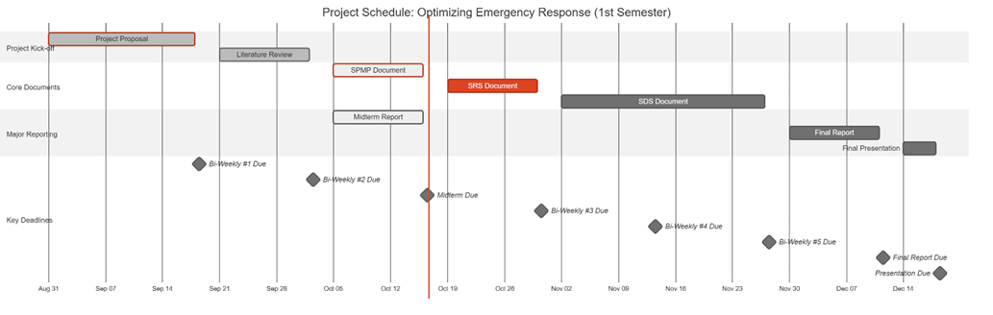
Figure 2: Gantt Chart: Project Schedule

3.3.3.3 Quality Control
The quality assurance will be ensured by the strict testing and following the standards defined. The main quality requirements are:
- Model Performance: The AI model should obtain a high accuracy, precision and recall on a special test set.
- System Performance: The video streams should be processed by the system with low latency to achieve real-time processing.
- Code Quality: The code will be version-controlled, documented, and peer-reviewed.

3.3.3.4 Reporting
The team and the supervisor will maintain constant communication and transparency on the status of the projects through a well-organized reporting system.
- Team Meetings: Meeting will take place on a weekly basis with internal members to report progress and address any arising issues and to discuss future functions. There will be recording of minutes, which will be distributed among the members.
- Bi-Weekly Reports: As required by the course syllabus, formal progress reports will be presented to the supervisor after every two weeks where information on the work done, status and further plans of the next cycle will be given.
- Milestone Reports: This will include major deliverables that will be prepared and presented formally to be reviewed by the supervisor and the evaluation committee, including the Mid-Semester and Final reports. Such reports will give a detailed review of the project progress and success at the critical points.

3.3.3.5 Project Metrics
Quantifiable metrics will be used to track the performance of the project.
Metric | Description | Frequency
Schedule Variance | Measures the deviation from the planned schedule to identify delays early. | Weekly
Model Accuracy | Quantifies the model's detection performance (mAP, F1-Score). | Per Training Cycle
System Stability | Tracks the number of critical bugs identified and resolved during testing. | During Testing Phases
Table 13: Key Project Metrics

3.3.4 Risk Management Plan
There are possible risks in the project that are identified in this plan and proactive measures to capture the effect of these risks.
Risk ID | Risk Description | Probability | Mitigation Strategy | Impact
R1 | Data Scarcity/Poor Quality: Lack of sufficient or diverse accident footage for robust model training. | Moderate | Proactively aggregate data from multiple public sources; employ data augmentation techniques. | Quality, Schedule
R2 | Low Model Performance: The trained model fails to achieve the desired accuracy for reliable, real-world detection. | Moderate | Experiment with various state-of-the-art model architectures and conduct extensive hyperparameter tuning. | Quality
R3 | Insufficient Computing Power: Local hardware is inadequate for training the deep learning model efficiently. | High | Establish and test access to cloud GPU platforms (e.g., Google Colab Pro) as a primary or backup solution. | Budget, Schedule
R4 | Time-Consuming Annotation: Manual labeling of video frames takes longer than allocated in the schedule. | Moderate | Utilize efficient annotation tools (e.g., CVAT) and distribute the workload evenly among team members. | Schedule
Table 14: Risk Management Plan

3.3.5 Project Closeout Plan
The project closeout phase will be used to ensure that the project is professional and in an orderly manner ended.
- Final Verification: Making sure that all systems functions and requirements have been covered.
- Project Archiving: The project materials such as source code, trained models and documentation will be arranged and archived on GitHub.
- Final Reporting: It will produce a final report and user manual that has undergone a review and is submitted.
- Knowledge Transfer: The group will provide a final presentation and hold a session of lessons learned to document lessons learned that will be used in future projects.

3.4 Technical Process Plans
This section includes process models, methods, tools, and techniques. Moreover, it includes infrastructure and product acceptance.

3.4.1 Process Model
The Waterfall model was selected as the primary software development approach for this project, Optimizing Emergency Response, because of its structured, sequential, and documentation-oriented nature. Each phase produces a set of deliverables that serve as verified inputs to the next phase. Given that this project follows academic supervision, institutional milestones, and fixed submission deadlines, the Waterfall model ensures systematic progress and traceable quality control across all development stages.

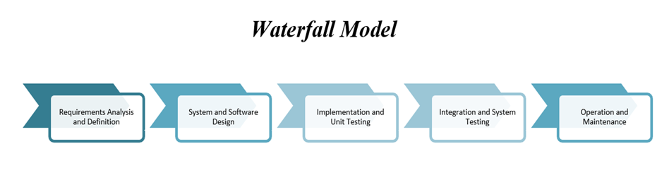
Figure 3: The Waterfall Model
Table 13 shows the waterfall phases, along with their Phase, Duration, Description, Main Activities, Deliverables and Outcomes.
Phase | Duration | Description | Main Activities | Deliverables / Outcomes
1. Requirements Analysis | Nov 1 – Nov 20 2025 | Identify, analyze, and document all functional and non-functional requirements for the system. | • Gather requirements from literature and emergency response protocols.• Define system functions (accident detection, alert generation, and reporting).• Specify hardware & software constraints, datasets, and ethical considerations. | • Software Requirements Specification (SRS).• Use-case and context diagrams.• Dataset description document.
2. System and Software Design | Nov 21 – Dec 10 2025 | Translate the requirements into detailed architecture and technical design. | • Design overall system architecture (camera feed → YOLOv8 model → alert module).• Define data flow and database structure.• Select frameworks and AI tools (TensorFlow 2.x, PyTorch, OpenCV). | • Software Design Specification (SDS).• Architecture and dataflow diagrams.• Database schema and interface design.
3. Implementation (Coding) | Dec 11 – Jan 10 2026 | Convert the design into executable modules and integrate the core AI model. | • Develop and train YOLOv8 and CNN models on labeled datasets.• Implement real-time accident detection and alert system in Python.• Develop API and dashboard interface for emergency notifications.• Use GitHub for version control and continuous testing. | • Trained AI models.• Source code repository.• Integrated prototype with detection and alert modules.
4. Testing and Verification | Jan 11 – Jan 25 2026 | Validate that the system meets specified requirements and performance targets. | • Conduct unit testing for each module.• Perform integration and system testing.• Evaluate accuracy (Precision, Recall, F1-Score).• Simulate accident scenarios for response time testing. | • Software Testing Plan (STP).• Test reports and performance metrics.• Validated system ready for deployment.
5. Deployment and Integration | Jan 26 – Feb 5 2026 | Deploy the validated system for demonstration and evaluation. | • Deploy system on cloud platform (Google Colab or AWS EC2).• Integrate real-time video feed for testing.• Prepare user manual and presentation materials. | • Operational prototype demonstration.• Deployment report.• User manual and demo video.
6. Maintenance and Enhancement | Feb 6 – Feb 20 2026 | Conduct system review, bug fixes, and enhancements based on feedback. | • Resolve issues from testing and presentation reviews.• Optimize model parameters and update dataset.• Document lessons learned and future improvements. | • Updated system version.• Maintenance log.• Final project closure report.
Table 15:The Waterfall Phases

3.4.2 Methods, Tools, and Techniques
This section describes the software development methods, tools, and techniques utilized throughout the project Optimizing Emergency Response. The project integrates Artificial Intelligence, computer vision, and web technologies to detect car accidents in real time using live surveillance footage. The adopted methods focus on ensuring high detection accuracy, efficient model performance, and seamless communication with emergency services. The tools and frameworks were selected based on their reliability, open-source support, and suitability for AI-based computer vision applications.

Category | Tool / Framework | Purpose / Description
Development Environment | Python 3.10 | Primary programming language for system development, AI modeling, and automation.
AI & Deep Learning Frameworks | YOLOv8 (Ultralytics) | Used for real-time object and accident detection in traffic footage. Offers state-of-the-art accuracy and fast inference speed.
 | TensorFlow 2.x / PyTorch | For training and fine-tuning Convolutional Neural Network (CNN) models and integrating YOLOv8 models.
Computer Vision Library | OpenCV | Used for video stream handling, frame extraction, and pre-processing of camera footage.
Data Labeling and Preparation | LabelImg / Roboflow | Tools for annotating accident datasets and managing dataset versions for model training.
Database Management | MySQL / SQLite | Used to store incident records, alert logs, and user information.
Backend Framework | Flask (Python) | Lightweight web framework used to handle the system’s API for alert generation and response communication.
Frontend Development | HTML, CSS, JavaScript (React optional) | Used to design the monitoring dashboard for displaying live detection and alerts.
Version Control | Git & GitHub | For collaborative source code management, version control, and tracking development progress.
Testing Tools | PyTest / Unittest | Used for unit and integration testing of modules to ensure system stability and correctness.
Deployment Platform | Google Colab / AWS EC2 | Used for model training, testing, and hosting the prototype in a cloud environment.
Project Management & Documentation | Microsoft Word / Excel / Trello | Used for documentation, scheduling tasks, and progress tracking throughout the development cycle.
Table 16: Used Tools

3.4.3 Infrastructure
This section outlines the hardware and software infrastructure used in each development phase of the Optimizing Emergency Response project. The infrastructure was selected to support deep learning model training, real-time video processing, and deployment of the system prototype. Each phase of the Waterfall model relies on specific tools and environments to ensure efficiency, accuracy, and scalability.

Project Phase | Tools / Infrastructure Used
Requirements Analysis | Microsoft Word, Excel, Trello, Google Drive
System and Software Design | Draw.io, Lucidchart, Visual Paradigm, MySQL Workbench
Implementation (Coding) | Python 3.10, TensorFlow 2.x, PyTorch, YOLOv8, OpenCV, Flask
Testing and Verification | PyTest, Unittest, Jupyter Notebook, Confusion Matrix Metrics
Deployment and Integration | Google Colab, AWS EC2, GitHub, Flask Server
Maintenance and Enhancement | GitHub Issues Tracker, Google Colab, MySQL, Documentation Tools
Table 17: The Essential Requirements

3.4.4 Product Acceptance
This section defines the criteria and procedures that will be followed to ensure the Optimizing Emergency Response system meets its intended objectives and quality standards before final submission and deployment. Product acceptance is based on verifying that all functional and non-functional requirements are satisfied, that the system performs reliably in real-time environments, and that it operates according to its design specifications.

3.5 Supporting Process Plans
This section outlines the documentation standards, responsibilities, and review procedures followed throughout the Optimizing Emergency Response project. All project documents are prepared in accordance with the relevant IEEE standards and university-provided templates to ensure consistency, accuracy, and traceability across all development phases. Each document is collaboratively prepared by the project team and reviewed under the supervision of Dr. Aftab, ensuring that all deliverables meet academic and professional quality standards before submission.

Document Type | Format Standard | Prepare Document | Review Document
Introduction and Literature Review | Provided by the supervisor | All team members | Project Supervisor: Dr. Aftab
Mid-Semester Report | Provided by the supervisor | All team members | Project Supervisor: Dr. Aftab
Software Project Management Plan (SPMP) | IEEE Standard 1058-1998 | All team members | Project Supervisor: Dr. Aftab
Software Requirements Specification (SRS) | IEEE Standard 1058-1998 | All team members | Project Supervisor: Dr. Aftab
Methodology | Provided by the supervisor | All team members | Project Supervisor: Dr. Aftab
Software Design Specification (SDS) | IEEE Standard 1058-1998 | All team members | Project Supervisor: Dr. Aftab
First Semester Final Report | Provided by the supervisor | All team members | Project Supervisor: Dr. Aftab
Software Test Plan | IEEE Standard 1058-1998 | All team members | Project Supervisor: Dr. Aftab
User Manual | IEEE Standard 1058-1998 | All team members | Project Supervisor: Dr. Aftab
Senior Project Source Code and Report | Provided by the supervisor | All team members | Project Supervisor: Dr. Aftab
Table 18: Supporting Process Plans

3.6 Additional Plans
This section describes the supporting considerations for data handling, documentation, system operation, and compliance with ethical and legal standards. These plans help ensure the project is properly organized, secure, and adaptable to different use contexts.

3.6.1 Data Privacy and Security
All datasets used in this project are publicly available and pre-annotated. No personal information is collected or stored. Data processing is performed locally to maintain security and control. Appropriate care will be taken to ensure data is used responsibly and handled according to standard academic and institutional guidelines.

3.6.2 Documentation and User Operation
A structured set of instructions will accompany the system, detailing the environment setup, model execution steps, and how to view and interpret results. This documentation ensures that the system can be operated consistently and understood clearly by authorized users.

3.6.3 Maintenance and Updates
The project resources, including the source code and model files, are organized to support proper tracking and structured management. This organization facilitates adjustments or technical refinements when necessary, without requiring major system changes.

3.6.4 Deployment Considerations
The system is developed to operate on standard computing environments. Its structure allows it to be integrated with external components or operational setups as needed. The design emphasizes modularity, making it easier to adapt the system to different configurations or extend its functionality when required.

3.6.5 Ethical and Legal Considerations
The system complies with ethical standards by avoiding the use of any personal data and ensuring responsible handling of input sources. In all cases, data usage and system operation are expected to align with relevant legal and regulatory frameworks concerning surveillance and information security.

Chapter 4: Software Requirements Specification (SRS)

4.1 Introduction
This Software Requirements Specification (SRS) document describes the requirements for the project Harnessing Deep Learning to Optimize Emergency Response. It defines the overall purpose, features, and behavior of the system, along with its expected performance and interaction with users. The document serves as a guide for the project team, supervisor, and evaluators, ensuring that all members share a clear understanding of what the system will do and how it will operate.

4.1.1 Purpose
The purpose of this Software Requirements Specification (SRS) is to clearly define and document the functional and non-functional requirements of the proposed system. It provides a foundation for design, development, and testing, ensuring that the system aligns with its intended goals of accuracy, reliability, and usability. This document also facilitates communication by establishing a shared understanding of the system’s objectives, scope, and constraints.

4.1.2 Scope
This project has in its goal the designer, tester, and implementation of a real-time emergency response optimization system which utilizes deep learning for the detection of accidents. It takes in real-time video streams from traffic cameras and uses YOLO and CNN algorithms to recognize car crashes. Then, it initiates the alert procedure for the emergency responders (police, ambulance, fire services) automatically. By covering the whole process from detection to alert creation, the system supports live deployment all day, every day aiming at cutting down emergency response time and enhancing road safety.

4.1.3 Definitions, Acronyms, and Abbreviations
- Definitions
  - Accident Detection: the entire procedure of letting machines see and learn to detect accidents through the application of state-of-the-art technology in vision processing and deep learning is carried out using video clips in real time monitoring.
  - Alert Generation: immediately after the accident is detected, the alerts are generated and sent to the emergency response services.
  - Deep Learning: the area of machine learning that relies on extremely complex and layered neural networks to identify very subtle patterns among the colossal amount of data.
  - Real-time Processing: it is a video processing performance that recognizes accidents at a maximum duration of 2 seconds (the target is to make the delay shorter than 2 seconds).
  - Model Training: the process of teaching a neural network to recognize accident detection patterns through a dataset that has labeled training examples.
- Acronyms
Acronym | Definition
AI | Artificial Intelligence
API | Application Programming Interface
ARTI | Artificial Intelligence (course code)
AWS | Amazon Web Services
CNN | Convolutional Neural Network
CCTV | Closed-Circuit Television
CVAT | Computer Vision Annotation Tool
GPU | Graphics Processing Unit
IEEE | Institute of Electrical and Electronics Engineers
mAP | Mean Average Precision
OpenCV | Open Source Computer Vision Library
QA | Quality Assurance
SDS | Software Design Specification
SPMP | Software Project Management Plan
SRS | Software Requirements Specification
STP | Software Test Plan
STS | Software Test Specification
UI/UX | User Interface/User Experience
YOLO | You Only Look Once (object detection architecture)
Table 19: Glossary of Acronyms and Abbreviations

4.1.4 References
- IEEE Std 1058-1998, IEEE Standard for Software Project Management Plans, Institute of Electrical and Electronics Engineers, 1998
- IEEE Std 830-1998, IEEE Recommended Practice for Software Requirements Specifications, Institute of Electrical and Electronics Engineers, 1998
- IEEE Std 1016-1998, IEEE Recommended Practice for Software Design Descriptions, Institute of Electrical and Electronics Engineers, 1998
- ARTI 511 Course Syllabus, Term 1 2025-2026, Imam Abdulrahman Bin Faisal University, College of Computer Science & IT
- Ultralytics YOLOv8 Documentation, Available at https://docs.ultralytics.com, accessed October 2025
- TensorFlow Documentation, TensorFlow Core v2.20, Available at https://www.tensorflow.org
- PyTorch Documentation, PyTorch v2.90, Available at https://pytorch.org/docs
- OpenCV Documentation, OpenCV 4.12.0, Available at https://docs.opencv.org

4.2 Overall description
The product is a smart software system, which uses artificial intelligence and computer vision to track live video feeds and identify road incidents automatically. It runs live camera feeds through trained models to detect and categorize accidents, retains temporary footage to verify them, and directly transmits the relevant emergency response agencies including police, ambulance, and fire departments. It is an autonomous system as well as it does not require any direct interaction with the user and is instead used as a background monitoring system to assist emergency teams by providing proper, reliable and timely alerts. It may be used as a standalone solution, or work with the current city or agency infrastructure, guaranteeing that it will operate continuously under the different environmental and network parameters. The main aspects will be privacy, data processing, and reliability of the work, ensuring that the entire visual information is processed safely and the system does not drop even when the quality of input or connection is impaired.

4.2.1 Product perspective
The software is mainly a stand-alone program which may also have an integration as a part of a larger emergency management or smart city program. It independently observes live video streams, identifies an incident on the road, and is automatically able to dispatch structured messages to the emergency authorities, including police, ambulance, and fire services. The software can be integrated with the available dispatch or analytics platforms to share incident data and metadata of the camera to facilitate coordinated and prompt reactions. When used independently, it does the same monitoring and alerting functions on its own and has its own local database and communication interfaces.
Major Inputs and Outputs:
Inputs: Continuous live video streams from surveillance or traffic cameras, along with optional metadata such as camera identifiers and geographic coordinates.
Outputs: Automatically generated messages with event information, time and place of events, severity measurements, and graphical evidence, which are safely sent to assigned emergency response units or systems.

4.2.2 Product functions
The proposed system, Harnessing Deep Learning to Optimize Emergency Response, is designed to automatically detect and report car accidents using real-time video analysis powered by deep learning and computer vision. Its main functions work together to minimize human error and reduce emergency response time.

1. Real-Time Video Monitoring
- The system continuously receives live video streams from surveillance and traffic cameras placed across urban roads and intersections.
- Video feeds are processed in real time to ensure that the system can immediately analyze ongoing traffic events.
- A video buffering mechanism maintains short-term footage storage for immediate review or evidence collection.
2. Accident Detection Using Deep Learning
- The system uses AI models such as YOLO and Convolutional Neural Networks (CNNs) to detect accidents within video frames.
- Upon detection, the system validates the event to minimize false alarms, ensuring high accuracy and reliability.
3. Accident Classification and Severity Assessment
- After identifying an incident, the system classifies it by severity level (e.g., minor, moderate, or major crash) based on visual cues such as collision intensity, number of vehicles, and fire or debris presence.
- Severity classification helps emergency control centers allocate the right resources (ambulance, police, or fire services).
4. Automated Alert and Notification System
Once an accident is confirmed, the system automatically generates an alert that includes:
- Accident location (via GPS or mapped camera coordinates)
- Time and estimated severity
- Reference camera ID and a visual of the incident
The alert is then sent to relevant emergency units through mobile notification, or integration with emergency service platforms.
5. System Management and Monitoring Dashboard
Authorized users, such as emergency control staff, can access a centralized Emergency Response Dashboard.
The dashboard enables users to:
- View live camera feeds and add or remove connected Surveillance Nodes.
- Monitor real-time accident alerts and update linked Emergency Units (hospitals, fire departments, police stations).
- Review past incidents and generate analytics reports for performance and response tracking.
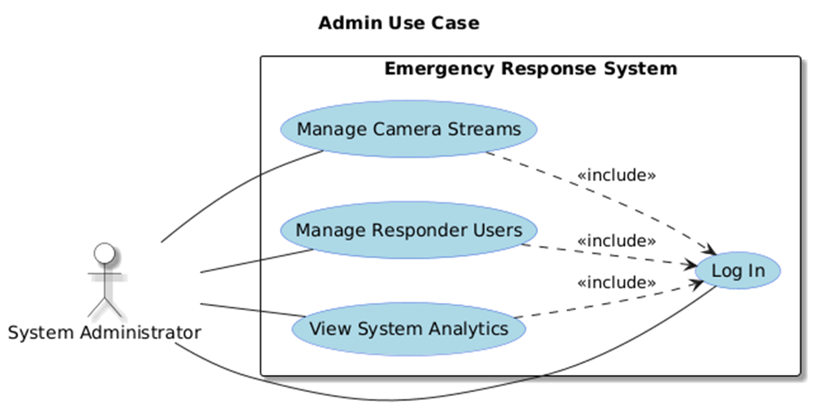
Figure 4: Admin Use Case

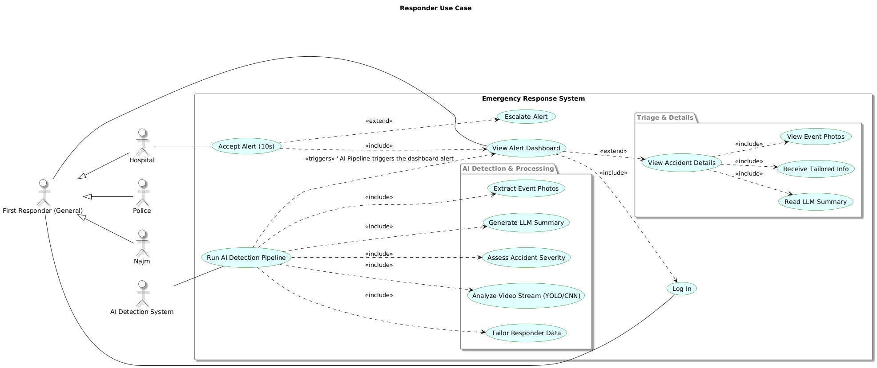
Figure 5: First Responders Use Case

4.3 Specific requirements
This section outlines the detailed functional and non-functional requirements of the Emergency Response Optimization System. It defines how the system will operate, including data input from surveillance cameras, real-time accident detection using deep learning models, alert generation, and communication with emergency units. The requirements specify user interactions, system performance, reliability, and security standards to ensure accurate detection, fast response, and seamless integration with existing smart city infrastructure.

4.3.1 External interface requirements
This section details the interfaces connecting the system to its users and other external components.

4.3.1.1 User interfaces
The system will provide a web-based graphical user interface (GUI) built using the React framework to ensure a responsive, modern, and high-performance user experience. The interface will be simple and intuitive, tailored to two primary user roles: System Administrator and First Responder User.

4.3.1.1.1 Common Interfaces

4.3.1.1.1.1 Login Interface
This is the secure entry point for all users.
Field | Format | Level | Input/Output | Comment
Username / Email | Text (Email format) | Required | Input | User's registered email address.
Password | Text (Masked) | Required | Input | User's secure password.
Login Button | Button | Required | Input | Submits credentials for authentication.
Forgot Password | Link | Optional | Input | Initiates password reset flow.
Error Message | Text (Red) | N/A | Output | Displays if authentication fails (e.g., "Invalid username or password").
Table 20: Login Interface

4.3.1.1.2 System Administrator Interfaces
Accessible after a user with "Admin" role logs in.

4.3.1.1.2.1 Admin Dashboard (Homepage)
Main navigation hub for the administrator.
Field | Format | Level | Input/Output | Comment
Header | Text | Required | Output | Displays "Administrator Dashboard" and logged-in user's name.
Navigation Menu | Links | Required | Input | Links to "Camera Management" and "User Management".
System Status | Text / Graphics | Required | Output | A summary view showing system health (e.g., "All systems operational").
Active Streams | Number | Required | Output | A count of currently active and processing video streams.
Logout Button | Button | Required | Input | Logs the administrator out of the system.
Table 21: Admin Dashboard Interface

4.3.1.1.2.2 Camera Management Interface
Allows the admin to add, view, and manage the city's camera streams ("Surveillance Nodes").
Field | Format | Level | Input/Output | Comment
Camera List | Table | Required | Output | Displays all registered cameras with their ID, Name, Stream URL, and Status (e.g., "Active", "Offline").
Add Camera Button | Button | Required | Input | Opens the "Add Camera" modal/form.
View Stream | Button | Optional | Input | Allows admin to view the live feed from the camera.
Edit/Delete | Buttons | Optional | Input | Allows editing or removing an existing camera from the list.
Camera ID (Form) | Text | Required | Input | A unique identifier for the camera (e.g., "CAM-001-KSA").
Camera Name (Form) | Text | Required | Input | A human-readable name (e.g., "King Fahd Rd @ Olaya St").
Stream URL (Form) | Text (URL) | Required | Input | The RTSP or HLS link for the live video feed.
Save Camera Button | Button | Required | Input | Saves the new camera to the system.
Table 22: Camera Management Interface

4.3.1.1.2.3 User Management Interface
Allows the admin to create, manage, and update "Emergency Units" (responder accounts).
Field | Format | Level | Input/Output | Comment
Agency List | Table | Required | Output | Displays all registered agencies (Hospital, Police, Najm) with their name, user email, and type.
Add Agency Button | Button | Required | Input | Opens the "Add Agency User" modal/form.
Agency Name (Form) | Text | Required | Input | e.g., "King Faisal Hospital ER" or "Najm - Riyadh".
User Email (Form) | Text (Email) | Required | Input | The login email for the new user account.
Agency Type (Form) | Dropdown | Required | Input | Options: "Hospital", "Police", "Civil Defense", "Najm".
Contact Number (Form) | Text (Phone) | Required | Input | Emergency contact number for alerts.
Save User Button | Button | Required | Input | Creates the new responder user account.
Edit/Delete | Buttons | Optional | Input | Allows editing or removing an existing agency account.
Table 23: User Management Interface
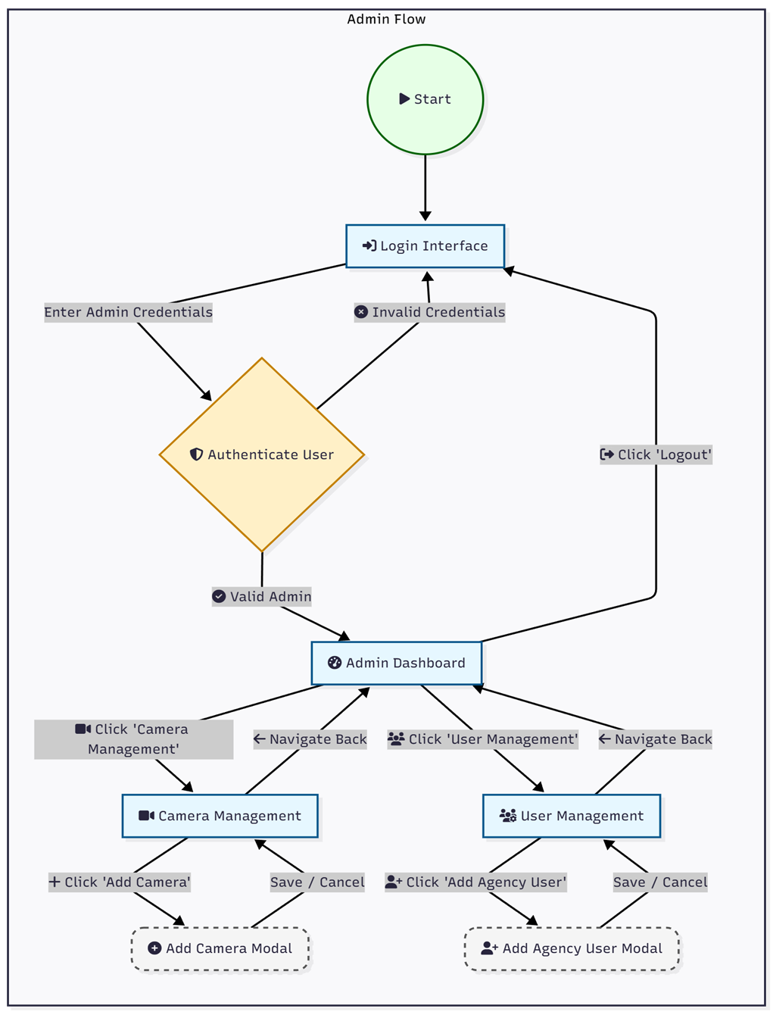
Figure 6: Admin workflow system

4.3.1.1.3 First Responder User Interfaces
Accessible after a user with a "Responder" role (e.g., Hospital, Police, Najm) logs in.
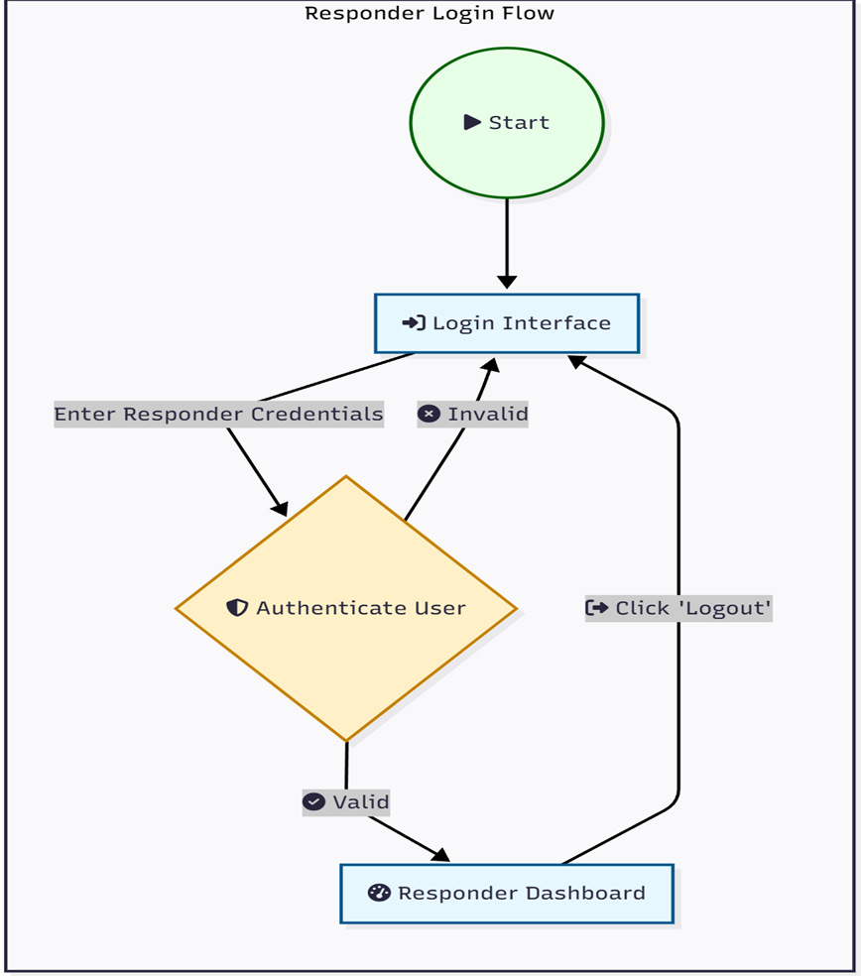
Figure 7: The Responders Login Flow

4.3.1.1.3.1 Responder Dashboard (Homepage)
Main dashboard for viewing and managing active accident alerts.
Field | Format | Level | Input/Output | Comment
Header | Text | Required | Output | Displays agency name (e.g., "King Faisal Hospital ER") and logged-in user.
Alerts List | List / Table | Required | Output | A list of active alerts, sorted by time (newest first). Each item shows location, time, and status (e.g., "New", "Accepted").
Alerts Map | Interactive Map | Required | Output | A map (e.g., OpenStreetMap) showing pins for all active accident locations.
Logout Button | Button | Required | Input | Logs the responder out.
Table 24: Responder Dashboard Interface

4.3.1.1.3.2 Accident Alert Interface (Modal)
This is the immediate notification that appears on the Responder Dashboard.
Field | Format | Level | Input/Output | Comment
Alert Title | Text | Required | Output | "!! NEW ACCIDENT DETECTED !!"
Location | Text | Required | Output | Address or GPS coordinates of the accident.
Time | Timestamp | Required | Output | Time of detection.
Accept Button | Button | Required (for Hospitals) | Input | Responder clicks to accept the case. after 10 seconds if not clicked/responeded, it will send to the second nearest hospital.
View Details | Button | Required | Input | Navigates to the full Accident Details Interface.
Timer | Countdown | Required (for Hospitals) | Output | A visual 10-second countdown timer.
Table 25: Accident Alert Interface

4.3.1.1.3.3 Accident Details Interface
This page provides the full, LLM-generated summary of the accident event.
Field | Format | Level | Input/Output | Comment
Case ID | Text | Required | Output | Unique identifier for the accident.
Location | Text & Map | Required | Output | Static map and text address.
Time of Incident | Timestamp | Required | Output | The time the accident was detected.
Accident Photos | Image Gallery | Required | Output | Key-frame snapshots captured by the AI.
Event Summary (LLM) | Text Block | Required | Output | A natural language summary of what happened (e.g., "A blue sedan collided with a white truck...").
Agency-Specific Info (LLM) | Text Block | Required | Output | This section is tailored.  - Hospital: "Estimated Injuries: 3"  - Najm: "Fault Assessment: 70% Blue Sedan, 30% White Truck."  - Police: "Vehicles: 2. Traffic Impact: High."
Action Log | Text | Required | Output | A log of actions (e.g., "Alert sent to KFH 14:32:01", "Alert accepted by KFH 14:32:08").
Table 26: Accident Alert Interface
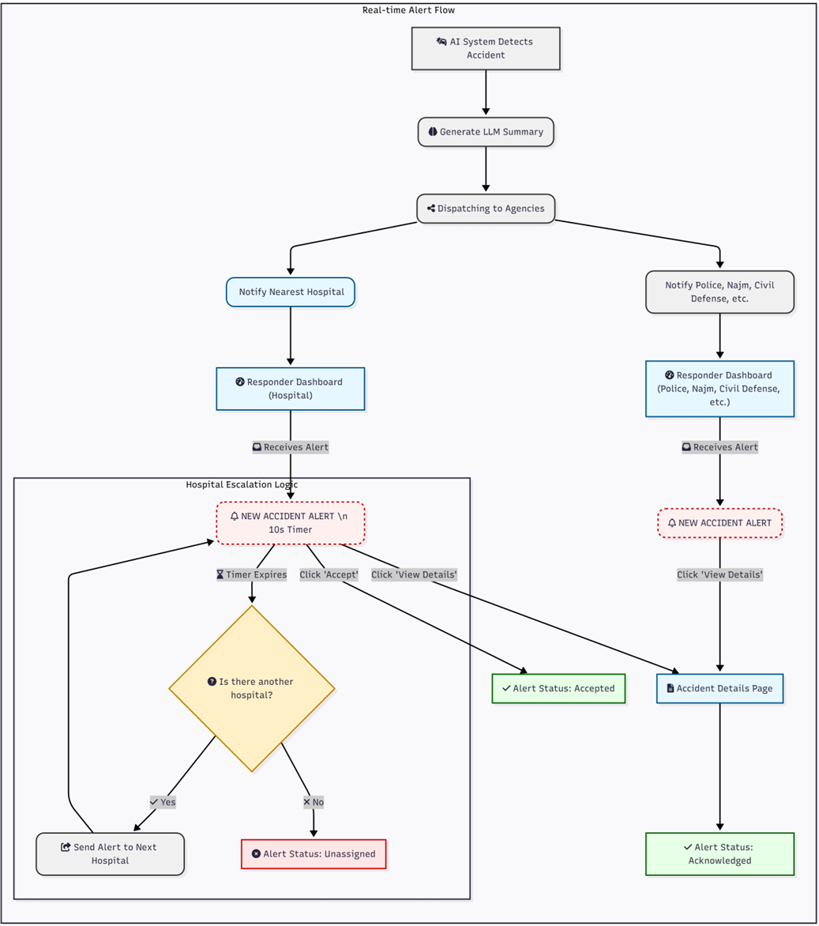
Figure 8: AI Alert System Flow

4.3.1.2 Hardware interfaces
- CCTV Cameras: The system will connect to IP-based surveillance cameras, to which it will purchase discoverable video streams (e.g. by RTSP or HLS).
- Application Server: The back end of the system is the system of AIs and a web server that will run on a high-performance server, which usually has between one and more GPUs to able deep learning inference.
- User Devices: The web-based user interface is going to be available on the normal desktop computers (e.g. dispatch centers) and also on the handheld devices (i.e. field responders) using modern web browsers.

4.3.1.3 Software interfaces
- AI Backend: The AI models (TensorFlow or PyTorch) will be serving out of a Python-based backend, based on frameworks like Flask or FastAPI, to the business logic of the system.
- Web Frontend: The client-side part will be a one-page application programmed in JavaScript, namely, in the React framework.
- Database: Data on users, camera metadata and logs of incident events will be stored in a relational database (or postgreSQL) or a non-relational database (or mongoDB).
- LLM API: The system will be calling upon external application programming interfaces to a big language model, like the Gemini API of Google, to produce brief summaries of accidents.
- Mapping API: The system will connect to a cartographic web service ( e.g., OpenStreetMap or the Google Maps API) to map spatially incident locations.
- Notification API: The system will be connected to a third-party telephony or short messaging service, like Twilio, in order to send emergency call alerts to responding agencies.

4.3.1.4 Communication interfaces
- HTTPS: The entire traffic between the users and the webserver will be encrypted using the HTTPS protocol.
- RTSP/HLS: The system will use the Real Time Streaming Protocol (RTSP) or the HTTP Live Streaming (HLS) to feed on the video feeds of cameras.
- WebSockets: To ensure the delivery of real-time alerts to the Responder Dashboard, the server will use a persistent WebSocket connection to dispatch the informatio.
- REST API: The Python backend will be connected to the React-based frontend through a secure RESTful API to exchange all the ancillary data transactions (e.g., authentication, the retrieval of inventories of the cameras).

Chapter 5: Software Design Specification (SDS)

5.1 Introduction
This Software Design Specification (SDS) details the architecture and organization of the "Harnessing Deep Learning to Optimize Emergency Response" system. It defines the architectural decisions, subsystems, interfaces, and data structures necessary to implement real-time video processing, deep learning accident detection, and automated emergency alert generation, serving as the essential blueprint for developers.

5.1.1 Purpose
The purpose of this SDS is to describe the complete design blueprint of the Real-Time Accident Detection and Emergency Alert System, outlining the system architecture, major components, data design, interfaces, and operational workflows. This document translates the functional and non-functional requirements defined in the SRS into detailed design elements that guide development, integration, and testing. It provides a shared technical reference for developers, testers and supervisors to ensure consistent understanding of how the system processes CCTV video streams, detects accidents using deep learning models, and dispatches alerts with minimal latency. This SDS forms the foundation for implementation and future system verification activities.

5.1.2 Scope
The scope of this SDS covers the full design of the accident detection and emergency alerting system, including the video processing pipeline, deep learning inference modules, alert dispatch mechanisms, data structures, and interface definitions. It describes the system’s architecture, constraints, operational behavior, and component responsibilities required to support continuous real-time monitoring. While the SDS focuses solely on the design of the software, related details such as testing procedures, deployment plans, and management activities are addressed in separate project documents.

5.1.3 Definitions, Acronyms, and Abbreviations

- Definitions
  - Accident Detection: the entire procedure of letting machines see and learn to detect accidents through the application of state-of-the-art technology in vision processing and deep learning is carried out using video clips in real time monitoring.
  - Alert Generation: immediately after the accident is detected, the alerts are generated and sent to the emergency response services.
  - Real-time Processing: it is a video processing performance that recognizes accidents at a maximum duration of 2 seconds (the target is to make the delay shorter than 2 seconds).
  - Incident Log: A persistent, timestamped record of every detected and confirmed accident, stored in the database for historical review and system auditing.
  - User Authentication: The process of verifying a user's identity (Admin or Responder) before granting access to the system's dashboards and data.
  - Latency: The time delay measured from when an event occurs in the video stream to when the system reports the final alert.
- Acronyms
Acronym | Definition
AI | Artificial Intelligence
API | Application Programming Interface
ARTI | Artificial Intelligence (course code)
AWS | Amazon Web Services
CNN | Convolutional Neural Network
CCTV | Closed-Circuit Television
CVAT | Computer Vision Annotation Tool
GPU | Graphics Processing Unit
IEEE | Institute of Electrical and Electronics Engineers
mAP | Mean Average Precision
OpenCV | Open Source Computer Vision Library
QA | Quality Assurance
SDS | Software Design Specification
SPMP | Software Project Management Plan
SRS | Software Requirements Specification
STP | Software Test Plan
STS | Software Test Specification
UI/UX | User Interface/User Experience
YOLO | You Only Look Once (object detection architecture)
Table 27: Glossary of Terms and Acronyms.

5.1.4 References
- IEEE Std 1058-1998, IEEE Standard for Software Project Management Plans, Institute of Electrical and Electronics Engineers, 1998
- IEEE Std 830-1998, IEEE Recommended Practice for Software Requirements Specifications, Institute of Electrical and Electronics Engineers, 1998
- IEEE Std 1016-1998, IEEE Recommended Practice for Software Design Descriptions, Institute of Electrical and Electronics Engineers, 1998
- ARTI 511 Course Syllabus, Term 1 2025-2026, Imam Abdulrahman Bin Faisal University, College of Computer Science & IT
- Ultralytics YOLOv8 Documentation, Available at https://docs.ultralytics.com, accessed October 2025
- TensorFlow Documentation, TensorFlow Core v2.20, Available at https://www.tensorflow.org
- PyTorch Documentation, PyTorch v2.90, Available at https://pytorch.org/docs
- OpenCV Documentation, OpenCV 4.12.0, Available at https://docs.opencv.org

5.2 System overview
The Harnessing Deep Learning to Optimize Emergency Response system is an autonomous, real-time traffic monitoring solution designed to reduce accident response times in urban areas. The system functions as a continuous intelligence pipeline that monitors live video feeds from cameras, detects car crashes using deep learning models, assesses incident severity, and automatically generates tailored alerts for first responders. It operates primarily as a background service with a dedicated web interface for authorized personnel (Police, Hospital, Fire Services) to view and manage alerts in real time. The core design is built for high availability and low latency, aiming to confirm and dispatch an alert in the least possible time after an accident occurring on the video stream.

5.2.1 System Functionality
The system is designed to fulfill three primary roles:
- AI Detection System: The core intelligence, responsible for video ingestion, frame-by-frame analysis using the AI models (YOLOv8/CNN) and generating a structured incident report upon confirmation.
- Alerting and Communication Engine: The module responsible for taking the structured incident report, generating a natural language summary using a Large Language Model (LLM), determining the nearest relevant responder, and initiating the alert escalation.
- Presentation and Management Layer: serves as the user-facing component of the system, implemented as a responsive web application. It is the centralized hub for system configuration and real-time incident response, ensuring that all user interactions are secure and role specific.

5.2.2 User Functionality
The system operates with two primary user roles: Admin and Responder. The following section outlines the specific functionalities granted to each.

5.2.2.1 Common Functionalities
Both Admin and Responder users can log into the system to access their functionalities.
- Enable Secure Authentication (Sign In/Sign Out).
- Allow Password Reset/Retrieval.
- Allow users to Update Profile (change contact info, password).
- Receive system Notifications and alerts.

5.2.2.2 Admin Functionalities
The Admin has full control over system configuration, user access, and resource management.
- Manage user accounts (Add, edit, and delete users).
- Manage agency permissions and roles for external units (e.g., Police, Civil Defense, and Hospitals).
- Add and remove hospitals and other response agencies from the system contact list.
- Manage surveillance infrastructure (Add, remove, and monitor cameras).
- Review and Export the System Audit Log.

5.2.2.3 First Responders Functionalities
The Responder manages real-time emergency incidents and coordinates response units.
- View Real-Time Alerts and Incidents (list and map view).
- Accept incoming alerts and initiate the response process.
- View detailed Accident Details (location, time, severity).
- Log all actions taken during incident response.
- View and Create New Incident Reports.
- Generate PDF reports for individual cases

5.3 Design Considerations
This section outlines the key issues, constraints, assumptions, and external factors that influence the system architecture and design decisions. Understanding these considerations ensures that the proposed design is realistic, maintainable, and compatible with the operational environment.

5.3.1 Assumptions and Dependencies
The design of the system is based on several assumptions and external dependencies that may affect its functionality or performance. These must be acknowledged to ensure consistency in implementation and deployment.

5.3.1.1 Related Software or Hardware
The system depends on the presence and performance of the following hardware and software components:
- The system requires working traffic or surveillance cameras providing stable, continuous video streams with adequate resolution and coverage for accurate accident detection.
- Processing hardware, either on a server or local machine, equipped with GPUs for deep learning tasks. Cloud-based GPU platforms can be used for training and inference if local resources are inadequate.
- Software Dependencies:
  - Python
  - Deep learning frameworks (TensorFlow / PyTorch)
  - OpenCV for video handling
  - Flask / Django for backend APIs
  - YOLOv8 model and necessary libraries
  - CVAT/LabelImg for dataset annotation

5.3.1.2 Network, Connectivity, and Streaming
- The system assumes stable network connectivity to continuously receive CCTV video streams without interruptions.
- Adequate bandwidth is required to handle real-time feeds from all connected cameras.
- Video streams should maintain a consistent frame rate (15–30 FPS) and resolution (720p or higher) for accurate detection.
- Low network latency is required to ensure real-time accident detection and timely alert generation.

5.3.1.3 Dataset Availability and Quality
- The system assumes access to publicly available accident and non-accident video datasets suitable for training and evaluating the deep learning models.
- It depends on accurate and consistent manual annotations (bounding boxes, accident labels) to ensure proper model learning.
- Training data is assumed to include sufficient variability in lighting, weather, camera angles, and traffic conditions to generalize well to real CCTV environments.
- The quality and resolution of dataset videos are assumed to be adequate for object detection models such as YOLOv8 (e.g., 720p or higher).
- Model performance is limited by the diversity and realism of the datasets, rare accident types may be underrepresented.

5.3.1.4 End-User Characteristics
The system will serve two main user groups assuming that they are familiar with basic computer systems and emergency response workflows:
1. Emergency Responders
- Require real-time, accurate alerts with minimal interface complexity.
- Typically non-technical users who rely on clear visuals and actionable information.
- Expect alerts containing time, location, severity, and detection confidence.
2. System Administrators
- Responsible for managing camera inputs, system updates, logs, and performance monitoring.
- More technically proficient (IT staff or trained operators).
- Require dashboard access to models, logs, camera settings, and alert statistics.

5.3.1.5 Possible And/Or Probable Changes in Functionalities
- Integration with Real CCTV Networks:
Currently, training uses public datasets. In the future, integration with live municipal camera networks may require changes to ingestion modules.
- Scalability Requirements:
The design may need to accommodate:
  - More cameras
  - Higher traffic density
  - Multiple processing nodes
- Deployment Changes:
Early versions may run locally, final versions may require:
  - Edge devices for real-time inference
  - Cloud-based distributed processing
- Model Updating:
Improvements in AI models may trigger migration to more efficient architectures.

5.3.2 General Constraints
The following inherent limitations have a great influence on software design and the consequent impact on the architectural and implementation options.

5.3.2.1 Hardware / Environment
- Constraint: Deployment involves the use of common computing nodes that have real-time video processing (edge devices or small servers).
- Impact: Model and pipeline optimization (frame sampling, model compression/quantization) in such a way that the system can meet low inference latency and fixed throughput on a limited hardware.

5.3.2.2 Software Stack & Libraries
- Constraint: System depends on Python 3.x and key libraries (OpenCV, PyTorch or TensorFlow for training, TensorRT for edge inference).
- Impact: Fix compatible library versions and provide reproducible environments to prevent conflicts during development and deployment.

5.3.2.3 Network & Camera Protocols
- Constraint: Live video is fed by CCTV/traffic video cameras using RTSP, nets may be limited by bandwidth or behind a NAT.
- Impact: Implement adaptive streaming, local buffering, and connection-resilient logic to maintain service despite variable network conditions.

5.3.2.4 Video Sources & Robustness
- Constraint: Video sources are heterogeneous (different codes, resolutions, frame rates) and connections may be intermittent.
- Impact: Use adaptive frame sampling, resolution fallback, and reconnect strategies so detection quality degrades gracefully rather than failing outright.

5.3.2.5 Performance & Latency
- Constraint / Design goal: The system should be capable of real-time or near real-time detection of accidents with low end to end delay.
- Impact: This involves the employment of efficient model architectures, regulation of the per-camera processing load, the employment of asynchronous pipelines, and minimization of the needless UI updates to make the system responsive to different workloads.

5.3.2.6 Storage & Capacity
- Constraint: Limited local storage; video and logs grow rapidly.
- Impact: Enforce rolling logs, TTL-based object retention, and configurable upload/archival to central storage.

5.3.2.7 Interoperability & Interfaces
- Constraint: It needs to be an always-on integrated system with external systems (including traffic control APIs and SMS gateways, webhooks).
- Impact: specification of stable JSON schemas, authentication (api keys/ HMAC) and failing on delays / backoff behavior when making external calls.

5.3.2.8 Security & Privacy
- Constraint: Protected data and privacy regulations apply; system must secure PII and video material.
- Impact: Encrypt data at rest and in transit, implement RBAC, audit logging, and optional face‑masking/anonymization features.

5.3.2.9 Standards & Documentation
- Constraint: Deliverables should also be based on institutional and IEEE-style of documentation and traceability practices.
- Impact: Have versioned documents, requirements traceability matrix and SDD/TEST change control.

5.3.2.10 Verification & Validation
- Constraint: Acceptance must be proven to display accuracy, latency and combination tests with representative streams.
- Impact: Test evidence and metrics Staged testing (unit) to simulated streams to live pilot.

5.4 User Interface Design
This section outlines the user interfaces and their design principles, including example screens and a description of the main screen elements and their actions.

5.4.1 Overview of User Interface
The user interface of the system is a secure role-based web platform and is equipped to work in real time. Depending on the role assigned to the user, the user is allowed access to certain functionality which is verified at the login point. There are two primary perspectives:
- System Administrator: The perspective of the administrator is centered on the health and set up of the system. Their primary dashboard will display the high-level view of the key performance indicators (KPI) such as the state of the system, active cameras, and the quantity of active incidents. At this main hub, they will be able to go out to modules and make use of the core parts of the system. This contains a Camera Management area to view, add or delete surveillance feeds, and User Management area where accounts to various responder agencies can be controlled. A detailed Audit Log also allows the administrators to overview all the major activities performed in the system in terms of its security and responsibility.
- First Responder: The view of the responder is functional and incident oriented. They are designed based on their experience. The main dashboard is an Active Incidents map which shows the actual geographical placement of all the emergencies in real-time and supplemented by a list of the most recent ones. This perspective is updated by default when the AI identifies new events. On the Incident Report page, rescuers are able to view a history of all incidents, which can be filtered and viewed chronologically. The selection of a particular incident will lead to an Accident Details screen, where all important information, such as a map and computer-generated summaries, will track the response between the detection until the resolution.

5.4.2 Interface Design Rules
The interface design is driven by the fact that it is necessary to be clear and fast in high pressure conditions.
- Clarity and Readability: The interface is developed on dark-mode theme with high contrast to reduce eye strain, which is normal in 24/7 command center layout. The display of the information is done in a clear typeface and understandable icons.
- Role-Based Simplicity: Role-based access is strictly adhered to in the system. There is only a navigation sidebar that contains links that are specific to the role of the logged-in user. This eliminates distractions of administrative environments to responders and secures sensitive settings to the operating personnel.
- Visual Status Feedback: The system provides a visual representation of the status of some of the critical components. Cameras are also specifically marked as Online or Offline, and the incidents marked with their status (e.g. New, Acknowledged, Scene Cleared) so that one can get an immediate overview.
- Layout Consistency: Each of the screens has a similar layout: on the left there is the main navigation sidebar, on the header is the title of the page, and there is a main content area. This uniform design enables the user to learn their way around the various modules easily and in a predictable fashion.

5.4.3 Screen Images
This section provides graphical representations of the most important user interfaces (UI) of the system, its structure, components and behavior. Each visual is described with a short explanation of what the interface is and how the user interacts with the interface.

5.4.3.1 Login Interface
This is the secure entry point for all users. The interface is divided into two parts where the system branding and other important functionalities (Real-Time Detection, Multi-Agency Coordination) appears on the left, and the login form is situated on the right. To access it, users fill their email and password. Password retrieval and fast access links are provided depending on the user roles.
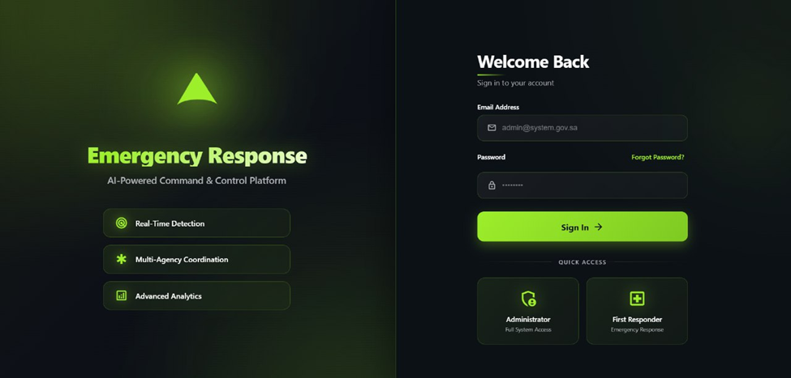
Figure 9: Secure emergency response login screen with system branding and role-based sign-in.

5.4.3.2 Reset Password Interface
It is a screen on which one can access a forgotten password. The user is requested to enter her registered email. It will then send by email, a reset link or verification code, to their email, to enable them to securely establish a new password.
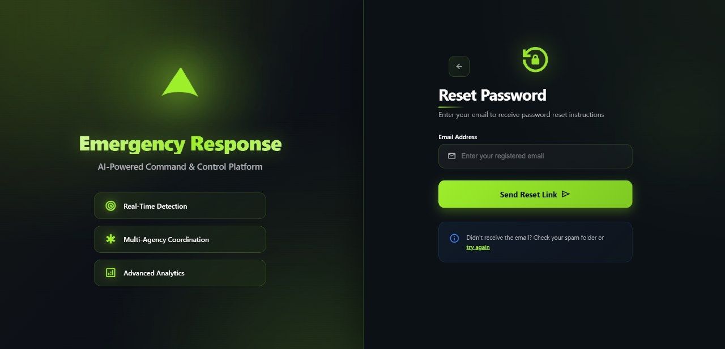
Figure 10: Reset Password Interface.

5.4.3.3 Administrator - Operational Dashboard
This is a landing page intended to be used by System Administrators and gives them a general report of the overall system health. It contains the main metric cards, which are the number of ongoing incidents, the number of active cameras, and the average response time.
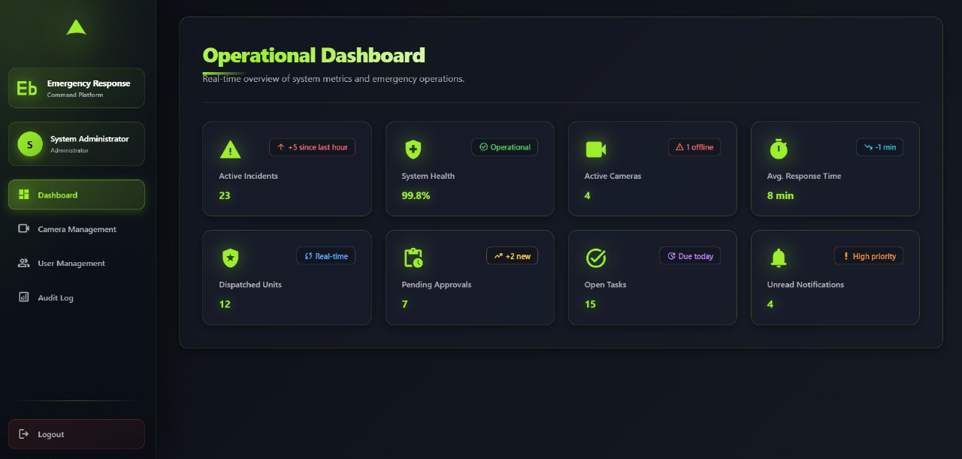
Figure 11: System Administrator Operational Dashboard.

5.4.3.4 Administrator - Camera Management
Through this screen, administrators can keep track of all the surveillance cameras attached and make all the necessary arrangements. It presents an outline of online, offline, and the total cameras. The main screen displays a grid of all registered cameras, each with their name, location and an obvious Online or Offline status badge. Via this page, administrators can add new cameras or update/delete those that are already in existence.
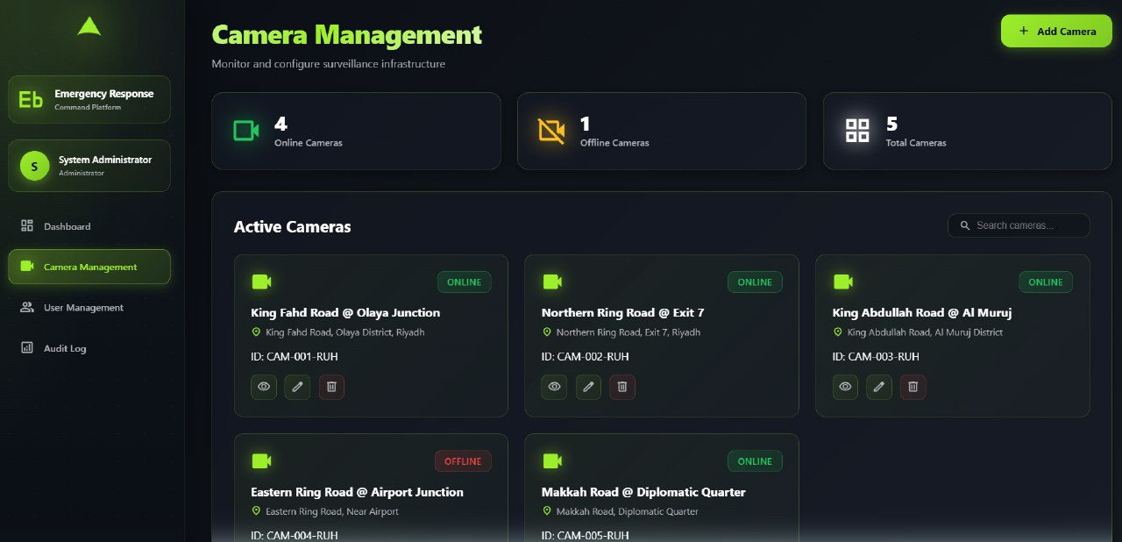
Figure 12: Camera Management Interface.

5.4.3.5 Administrator - User Management
The administrators use this interface to maintain the user accounts of all the external agencies. It gives a list of registered agencies (e.g. hospitals, police departments, civil defense) in a card format. The administrators have the capability to add new users to the agency or update and remove accounts to manage the system access.
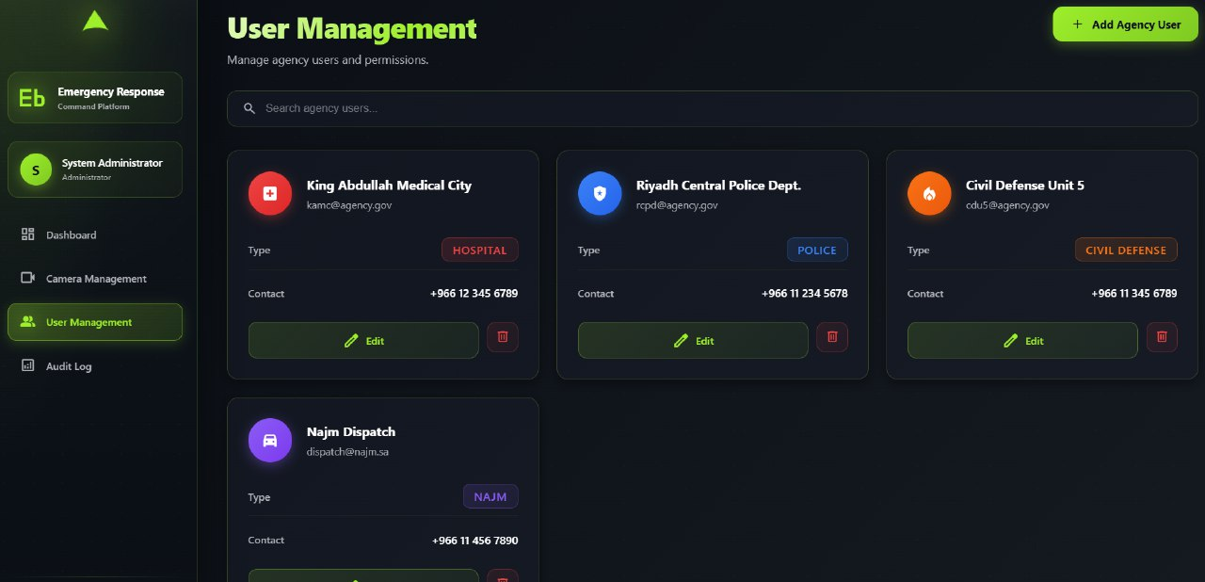
Figure 13: User Management Interface.

5.4.3.6 Administrator - System Audit Log
This screen provides a comprehensive, chronological record of system activities to ensure accountability and facilitate troubleshooting. The log captures all critical events, including user logins, camera additions / deletions or incident notifications, the user who performed the action, time and IP address. The log may be sorted by date, user or type of action.
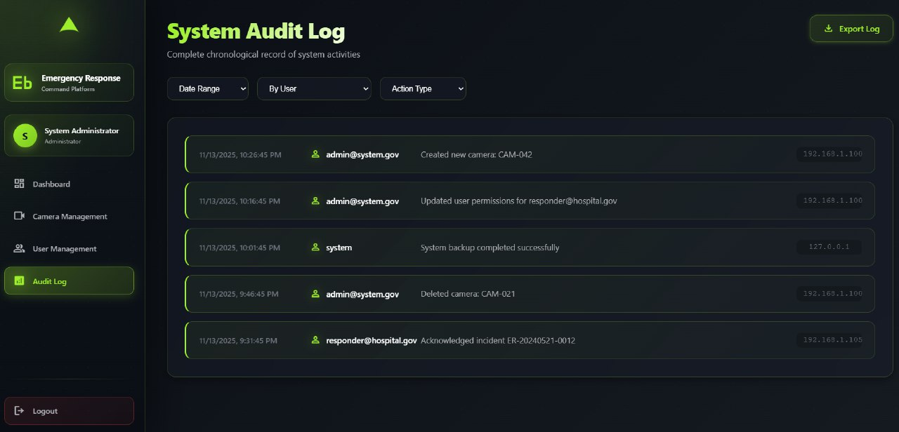
Figure 14: System Audit Log Interface.

5.4.3.7 First Responder - Active Incidents Dashboard
This is the main operational dashboard of First Responders. The interface is centered around an interactive map displaying the real-time locations of all active incidents, utilizing color-coded pins to indicate severity levels. On the left, there is a list of Recent Incidents that gives an overview of the new events when AI detects them.
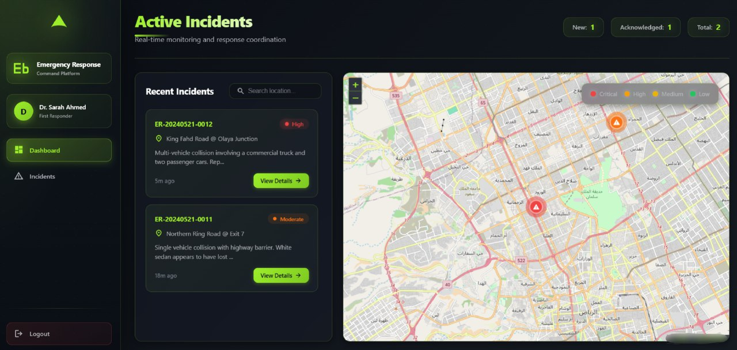
Figure 15: First Responder Active Incidents Dashboard.

5.4.3.8 First Responder - Incident Reports
This screen gives an historical view of all the past and ongoing incidences filterable. The responders are able to search according to the report ID or keyword and to filter according to the status (e.g., All, New, Acknowledged) or dates. The incidents are shown as cards that contain a summary, date and time with an option to open the full details.
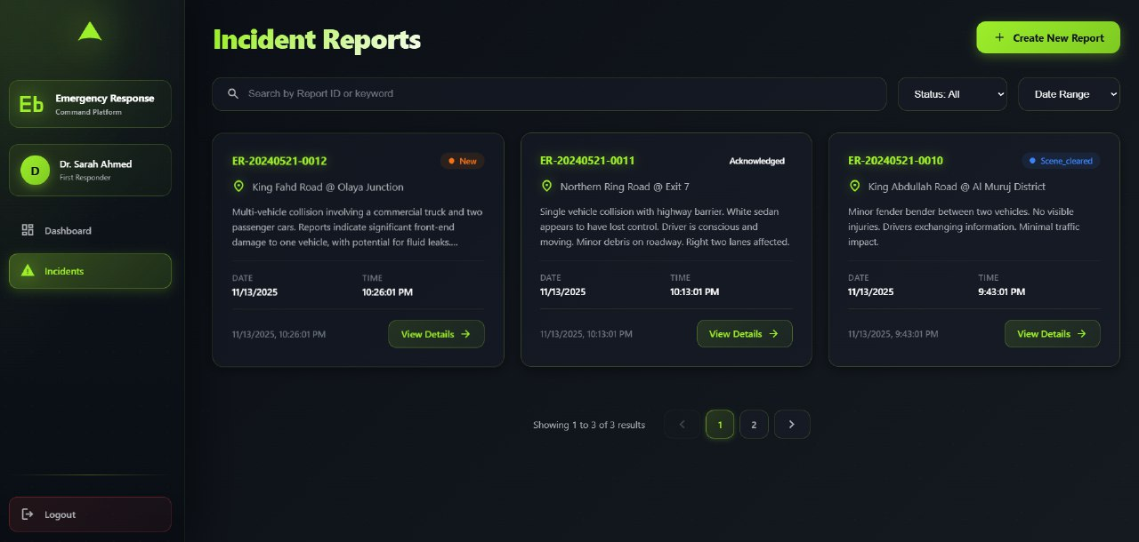
Figure 16: First Responder Incident Reports Interface.

5.4.3.9 First Responder - Accident Details
This is a screen that contains all the information on one incident that has been selected. It also includes a huge map of the specific location, the essentials of the incident (time, location text), and an eminent Action Log. It is a critical feedback mechanism; this log displays responders a live-updating timeline of everything that is happening.
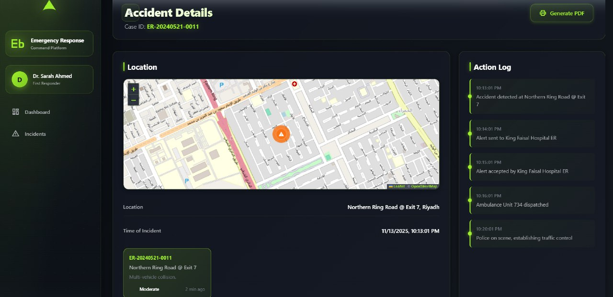
Figure 17: Accident Details Interface.

5.4.4 Screen Objects and Actions
In this section, the description of the common interface elements used in the system will be highly detailed, and the actions related to these elements will be described. In every screen, there are different interactive features, including buttons, links, icons and input fields, which allow users to navigate and interact with the system to its full capacity. The actions, type, and functionality of each element are described here to improve the interaction of the system as well as the usability.
Screen | Object Name | Object Type | Action / Description
Login | Email Address | Text Field | Allows the user to enter their registered email address.
Login | Password | Text Field | Enables the user to type his or her secure password (input is masked). Strategy: This should be minimum 8 characters, minimum 1 number, and 1 special character.
Login | Sign In | Button | Submits the entered credentials and attempts to log the user into the system. If this is the user's first login, redirect them to a 'Change Password' screen to enforce security.
Login | Forgot Password? | Link | Navigates the user to the password recovery screen.
Reset Password | Back Arrow | Icon Button | Navigates the user back to the Login screen.
Reset Password | Email Address | Text Field | Allows the user to enter their email to receive a password reset link.
Reset Password | Send Reset Link | Button | Validates the email and starts the password recovery process.
Admin Dashboard | Navigation Sidebar | Link List | Main menu for admins to navigate between dashboard, camera, user, and log pages.
Admin Dashboard | Metric Cards | Display | Read-only cards showing key system statistics such as active incidents and health.
Camera Mgt. | Add Camera | Button | Opens a form for the administrator to register a new camera feed.
Camera Mgt. | Search cameras... | Search Field | Filters the camera list by name or ID as the admin types.
Camera Mgt. | View (Eye Icon) | Icon Button | Opens a live video preview for the selected camera.
Camera Mgt. | Edit (Pencil Icon) | Icon Button | Opens a form to modify the selected camera’s settings.
Camera Mgt. | Delete (Trash Icon) | Icon Button | Removes the selected camera from the system after confirmation.
User Mgt. | Add Agency User | Button | Opens a form for the admin to create a new responder user account.
User Mgt. | Search agency... | Search Field | Filters the list of agency users by name as the admin types.
User Mgt. | Edit (on card) | Button | Opens a form to update the selected agency user’s account details.
User Mgt. | Delete (Trash Icon) | Icon Button | Removes the selected agency user account after confirmation.
Audit Log | Filter Dropdowns | Dropdown | Filters log entries by criteria such as date, user, or action type.
Audit Log | Export Log | Button | Downloads the filtered log as a file (for example, PDF or CSV).
Responder | Navigation Sidebar | Link List | Main menu for responders to switch between Dashboard (map) and Incidents views.
Dashboard | Recent Incidents | List | Live-updating list of new alerts; selecting an item opens its details.
Dashboard | Incidents Map | Map | Displays pins for the locations of all active emergencies.
Incident Reports | Search by Report ID… | Search Field | Helps the responder find a specific incident by its report identifier.
Incident Reports | Status / Date Range | Dropdown | Filters incidents by status and/or the date range in which they occurred.
Incident Reports | View Details | Link | Navigates to the full details page for the selected incident.
Accident Details | Generate PDF | Button | Creates a downloadable PDF summarizing all information for the current incident.
Accident Details | Action Log | List | Read-only timeline of all recorded response steps (for example, alert sent/accepted).
Table 28: User Interface Controls and Interactions.

5.4.5 Other Interfaces

5.4.5.1 Video Stream Ingestion Interface
- Description: This interface takes the live video feeds of the IP-based surveillance cameras which form the main source of data in the system.
- Technology/Protocol: The system is intended to consume feeds provided by cameras with the help of standard streaming protocols like RTSP (Real-Time Streaming Protocol) or HLS (HTTP Live Streaming).
- Initiation/Closure: The server makes and provides a permanent connection to the stream URL of the camera. This connection will be closed in the event that the camera will be pulled out of the system, or the service is discontinued.
- Error Conditions: Failing and interrupting of a stream connection will be recorded and a visual indicator reflecting the error will be displayed in the Camera Management dashboard showing the camera as being offline.

5.4.5.2 Client-Server API (REST)
- Description: This interface covers the main request-response of the user web- browser (frontend) to the backend server. It is utilized in the majority of actions that are initiated by a user, e.g., the logging in, camera list retrieval, or historical incident reports.
- Technology/Protocol: A secure RESTful API operating over HTTPS.
- Message Format: The exchange of all data is done through the use of JSON. An HTTP request is sent by the client (browser), and a server replies to it with a response in the format of JSON.
- Error Conditions: In case the request is rejected because of an authentication mistake (e.g. an expired session), the user is redirected to the login screen. In case the server has an internal error, a message of failed to load data will appear on the UI.

5.4.5.3 Real-time Alert Interface (WebSocket)
- Description: This interface offers two-way, real-time and constant communication between the server and the client. It is also critical in pushing live information to the customer, including new accidents and live updates to the Action Log, without the user having to refresh the page.
- Technology/Protocol: WebSockets (WSS).
- Initiation/Closure: A WebSocket connection is initiated by the browser of the client, once the client has successfully logged in. This relationship is open until the user logs off or closes the browser tab.

5.4.5.4 External Third-Party Service Interfaces
- Description: This stipulates how the system is related to the different external third-party services that offer expert, non-core services.
- Technology/Protocol: All external services are accessed via secure HTTPS REST APIs.
- Services Used:
  - AI/LLM Service: Used to send incident data and receive the AI-generated natural-language summaries for accident reports.
  - Mapping Service: Used to fetch the map tiles and geocoding data required to display the maps on the dashboards.
  - Notification Service: Meant to send alerts (e.g. SMS) to agency contact numbers in case of failure.

5.5 System Architecture
The system architecture provides a high-level view of how the Smart Emergency Response and Monitoring System is organized and how its main functions are structured and connected. This section describes the major subsystems, their responsibilities, and the way they interact to deliver real-time accident detection, event management, and emergency response coordination. The goal of this architecture is to ensure a modular, scalable, and efficient design where each component performs a specific role while working together seamlessly to support the overall system functionality.

5.5.1 Architectural Design Approach
The architectural design of the System follows a modular, layered, and service-oriented approach to ensure scalability, maintainability, and reliable performance during emergency situations. The system integrates multiple data sources such as live camera feeds, emergency unit locations (hospitals, fire departments, police), and administrative interactions. therefore requiring a clear and logical partitioning of responsibilities across subsystems.
High-Level Design Philosophy:
The system architecture was structured using three guiding principles:
- Separation of Concerns: Each subsystem handles a distinct functional responsibility (e.g., video processing, emergency unit management, user dashboard). This prevents overlap and reduces system complexity.
- Distributed Responsibility: To support real-time performance, processing-intensive tasks (e.g., accident detection using AI models) are isolated in specialized modules that operate independently but communicate via defined interfaces.
- Scalability and Extensibility: The design supports future additions such as new camera locations, integrating new emergency departments, or improving AI models without affecting the entire system.

The system was decomposed into subsystems based on the nature of the tasks and data flow:
- Video/AI processing tasks are computationally heavy and best isolated to avoid affecting user dashboard performance.
- Emergency resource management (hospitals, fire departments, police units) requires a structured backend subsystem for CRUD operations and live status management.
- Dashboard visualization is user-facing and must remain responsive; therefore, UI components are separated from backend logic.
- Database operations are centralized to ensure data integrity and avoid duplication.
- Notification and alerting mechanisms require a dedicated module to manage timing, communication, and routing of alerts.

Alternative architectures such as monolithic structure were rejected because they would make the system harder to scale, harder to maintain, and prone to performance bottlenecks especially around real-time video analysis.
At the highest level, the system must support:
- Real-time video collection and processing
- Automatic accident detection using AI/ML techniques
- Storing and retrieving system data (cameras, emergencies, units)
- Managing emergency response units (hospitals, firefighters, police)
- Displaying a centralized monitoring dashboard
- Generating alerts and event logs

Collaboration of Higher-Level Components
The collaboration between these subsystems follows a pipeline-like workflow:
- Camera feeds: processed by the Video Processing Subsystem
- Detected accident: forwarded to Event Management Subsystem
- Event details: stored in Data Management Subsystem
- Affected units: retrieved via Emergency Units Subsystem
- Alert + details: pushed to Notification Subsystem
- Updated information: displayed on Dashboard Subsystem
This layered interaction ensures that no subsystem is overloaded and that responsibilities are clearly distributed.

5.5.2 Architectural Design
The system is divided into six main modules:
- User Interface & Dashboard Module
- Video Acquisition & Accident Detection Module
- Emergency Event Management Module
- Emergency Units Management Module
- Notification & Alerting Module
- Data Management & Storage Module
Each module is independent but interconnected to support real-time detection, reporting, and management of emergency events.

1. User Interface & Dashboard Module
Role: Displays live camera feeds, accident alerts, emergency units, analytics, and management controls.
Responsibilities:
- Fetch system data through backend APIs
- Visualize accident events in real-time
- Provide administrators with CRUD interfaces for cameras, hospitals, and departments
Collaboration:
- Retrieves processed results from Event Management
- Displays data stored in the Data Management subsystem

2. Video Acquisition & Accident Detection Module
Role: Processes live camera feeds and detects accidents using computer vision / machine learning.
Responsibilities:
- Connect to camera streams
- Run AI models
- Send detection results to the Emergency Event Management Module
Collaboration:
- As soon as an accident is detected, it notifies the Event Management module
- Logs critical frames into the database

3. Emergency Event Management Module
Role: Central controller of all accident-related events.
Responsibilities:
- Create and manage accident event objects
- Update event status (detected, verified, resolved)
- Coordinate with Notification and Units Management modules
Collaboration:
- Receive detection signals from the Accident Detection module
- Stores event details in the Data Management subsystem
- Send alerts to the Notification Module

4. Emergency Units Management Module
Role: Manages hospitals, fire departments, police units, and their statuses.
Responsibilities:
- Add, remove, or edit emergency unit details
- Maintain live availability status
- Provide nearest or available units to an event
Collaboration:
- Supplies Event Management with recommended response units
- Stores updated unit information in the database

5. Notification & Alerting Module
Role: Sends notifications to dashboard users and logs event updates.
Responsibilities:
- Issue alerts for new accidents
- Update users when event statuses change
- Integrate with future communication channels (SMS, email, etc.)
Collaboration:
- Triggers alerts based on data from Event Management
- Sends UI update signals to the Dashboard module

6. Data Management & Storage Module
Role: Provides centralized storage for all system data.
Responsibilities:
- Maintain camera data
- Store accident events, timestamps, severity
- Store emergency units information
- Provide APIs/repositories for all modules
Collaboration:
- Serves as the shared data layer for all modules
- Ensures data consistency and integrity

5.5.3 Subsystem Architecture
The system was decomposed into the selected subsystems to maximize modularity, reduce coupling, and isolate high-processing tasks such as video analysis into independent modules. Separating event orchestration from unit management ensures clearer responsibility boundaries and makes the system easier to scale and maintain. A dedicated notification subsystem improves reliability and avoids mixing alert logic inside business modules. A centralized data subsystem ensures consistency across all modules. Alternative designs such as a monolithic architecture were rejected due to performance, maintainability, and scalability limitations.
1. UI & Dashboard Subsystem
- Subcomponents:
  - UI Client (Browser / SPA) pages and components
  - UI API Gateway Proxy light server to route UI requests / SSE or WebSocket endpoints
  - Dashboard Renderer / Charts Module
  - Admin Management Pages (Cameras, Units)
- Responsibilities: render live feeds and event lists, allow CRUD for cameras/units, receive push updates.
- Exports/Interfaces: GET /api/events, GET /api/cameras, WS /ws/updates, POST /api/cameras, PUT /api/units/:id.

Internal Interaction Summary:
The UI Client sends all requests through the API Gateway Proxy, which forwards them to backend services. The Dashboard Renderer subscribes to WebSocket/SSE channels to display real-time accident updates. Admin Pages interact with the backend using CRUD APIs for cameras and units. All UI components rely on the shared data models retrieved from the Data Management subsystem.

2. Video Acquisition & Accident Detection Subsystem
- Subcomponents:
  - Stream Connector : connects to RTSP/HTTP camera endpoints
  - Frame Capture & Buffer frame extractor, keyframe storage
  - Preprocessing Pipeline resizing, normalization
  - Detection Engine ML model(s) (object detection, anomaly classifier)
  - Local Cache / Short-term Storage stores recent frames and detection metadata
  - Detector-to-Event Adapter formats detection into Event object and posts to Event Management
- Responsibilities: reliably ingest streams, run detection models in near real-time, forward detections.
- Exports/Interfaces: POST /events/detections (internal API), message queue topic detections.
Internal Interaction Summary:
The Stream Connector ingests live video streams and passes frames to the Frame Capture & Buffer module. Frames are preprocessed and forwarded to the Detection Engine, which runs the AI inference. Detection results are temporarily stored in the Local Cache and then converted to event-ready messages by the Detector-to-Event Adapter before being sent to the Event Management subsystem.

3. Emergency Event Management Subsystem
- Subcomponents:
  - Event Orchestrator creates/manages Event lifecycle (detected → verified → assigned → resolved)
  - Event Repository Adapter persists events via Data Management
  - Verification Service optional manual verification workflow (operator confirmation)
  - Assignment Engine selects candidate units (calls Units Management)
  - Event API layer APIs for CRUD and status updates
- Responsibilities: authoritative source for all event state, coordination with notification and units.
- Exports/Interfaces: POST /events, GET /events/:id, PUT /events/:id/status, publishes to events topic.
Internal Interaction Summary:
The Event Orchestrator manages the lifecycle of each event and interacts with the Verification Service when operator approval is required. The Assignment Engine retrieves available units from the Units Management subsystem and updates the event record via the Event Repository Adapter. The Event API exposes endpoints to the UI and publishes updates to the Notification subsystem.

4. Emergency Units Management Subsystem
- Subcomponents:
  - Units Repository CRUD for hospitals/fire stations/police units
  - Geolocation & Proximity Service compute nearest units to an event
  - Availability Tracker tracks unit status (available/assigned/offline)
  - Units API layer APIs for unit data and live status updates
- Responsibilities: maintain unit catalog and availability, respond to assignment queries.
- Exports/Interfaces: GET /units/nearby?lat=&lon=&radius=, PUT /units/:id/status.
Internal Interaction Summary:
The Units Repository stores all unit entities, while the Availability Tracker keeps status information updated. The Geolocation & Proximity Service computes the nearest units for an event. The Units API layer exposes this data to the Event Management subsystem to facilitate automatic or manual assignment.

5. Notification & Alerting Subsystem
- Subcomponents:
  - Alert Router decides recipients and channels
  - Push Notifier WebSocket/SSE to UI clients
  - External Notifier Adapter connectors for SMS/Email (future)
  - Notification Audit Log store sent-notifications
- Responsibilities: reliably deliver alerts and updates; retry/fallback logic.
- Exports/Interfaces: POST /notify/event/:id, WebSocket channel /ws/updates.
Internal Interaction Summary:
The Alert Router receives event updates and determines routing logic. The Push Notifier delivers these alerts to dashboard users via WebSocket/SSE channels. The External Notifier Adapter prepares optional SMS/Email notifications. All outgoing alerts are logged by the Notification Audit Log.

6. Data Management & Storage Subsystem
- Subcomponents:
  - Relational DB (Postgres) canonical event, unit, user tables
  - Object Store (S3) video clips, keyframes, logs
  - Repository Layer / DAOs typed access to storage
  - Analytics Cache / OLAP store (optional) aggregated metrics for dashboard
- Responsibilities: durable persistence, transactional integrity, efficient queries for UI and services.
- Exports/Interfaces: DB schema, repository APIs, migration scripts.
Internal Interaction Summary:
The Repository Layer provides structured access to the relational database. The Object Store manages large media (e.g., detected accident frames). Analytics Cache stores aggregated metrics for fast dashboard queries. All subsystems interact with this module through repository classes or direct queries exposed by the API layer.

Functional high-level Data Flow Diagram (DFD)
[Camera Streams] à (Video Acquisition & Detection)
(Video Acquisition & Detection) à detection messages à (Event Management)
(Event Management) ßà (Units Management)
(Event Management) à (Notification & Alerting) à (UI & Users)
(UI & Dashboard) ßà (Data Management & Storage)
(All subsystems read/write) à (Data Management & Storage)

Key data items:
- Camera metadata (id, location, RTSP URL)
- Detection payload (timestamp, camera_id, confidence, bbox, clip ref)
- Event record (id, severity, status, assigned_units, timestamps)
- Unit record (id, type, location, availability, contact)
- Notification record (recipient, channel, status)
This DFD highlights a pipeline: Ingest à Detect à Event à Assign/Notify à Display à Persist.

Object-Oriented view (subsystem model & key classes)
core classes and relationships:
Class: Camera
- id, location, rtsp_url, status
Class: Detection
- id, camera_id, timestamp, confidence, bbox, clip_uri
Class: Event
- id, detections[], severity, status, assignedUnits[], created_at, updated_at
Class: Unit
- id, type, location, availability, contact
Class: Notification
- id, event_id, recipient, channel, sent_at, status

Sequence Diagram Descriptions
A. Accident Detection → Event Creation Sequence
1. Camera stream arrives to Stream Connector.
2. Frame is extracted by Frame Buffer.
3. Detection Engine analyzes frame and identifies accident.
4. Detector-to-Event Adapter sends a detection payload.
5. Event Management creates a new Event.
6. Event Repository saves event in database.
7. Notification Module sends “New Event” alert to UI.
8. UI Dashboard updates in real-time.

B. Event Verification and Unit Assignment Sequence
1. Operator views event on UI dashboard.
2. Operator clicks "Verify Event".
3. UI calls PUT /events/:id/status.
4. Event Orchestrator updates status to "verified".
5. Assignment Engine requests nearby units from Units Management.
6. Units Management returns list of available units.
7. Event Management assigns recommended units.
8. Notification Module sends assignment notifications.
9. Dashboard refreshes with assigned units.

5.6 Data Design
This section will represent an in-depth analysis of the data architecture of the system, which includes the description of how the information domain presented in the SRS, which consists of the real life objects, including users, surveillance cameras, and emergency incidents, is converted into structured and persistent data structures. The design can meet the important requirement of real-time responsiveness, high reliability and data integrity demanded to support emergency operations.

5.6.1 Data Description
The information domain of the system is pegged on four main concepts, including: Users (including administrators and responders), Cameras (which are the surveillance nodes), Alerts (which are the accident events), and the Audit Log (a detailed record of all the actions). This domain is then modeled and realized in form of normalized and relational database tables.
The key data entries are held and handled in the following fashion:
- User Data (Users): It is a repository of all data necessary to carry out authentication (login credentials) and authorization (role). This data is greatly processed by the Web Server (API) to handle the user sessions and control access to system functions a process that is confirmed by the User Management and the login screen.
- Camera Data (Cameras): This object maintains the parameters of configuration of each of the video streams being followed by the system. The Admin communicates with this organization through the Web API, and then the data is processed by the AI Processing Service. The AI service reads this table to determine the RTSP streams to read, which is confirmed by the “Camera Management” screen.
- Alert Data (Alerts): This is the most vital and dynamic data represented by this entity. When an accident is detected, it is instantiated by the AI Processing Service. The object has AI-generated data (severity, summaries) and event data (time, location, human-readable ID). Then the Real-time Service and the Web Server (API) process it to record responder actions, and this is supported by active Incidents screen and the Accident Details screen.
- Log Data (AuditLog): This is a system-wide log of all important actions. All other services update and create it. An example is Web Server logs which capture login and camera creation entries and AI Service logs capture alert detection, and Responder Portal logs capture alert acknowledgments. The given design is directly aligned with the screenshots of the System Audit Log and Action Log.
A PostgreSQL relational database will be used as the main data storage medium. This technology has been chosen due to its high reliability, transactional integrity (ACID compliance), and high ability to support standard relational data (users, cameras) as well as the semi-structured data (via JSONB or TEXT type when summarizing LLM results).

5.6.2 Data Dictionary
This table provides a comprehensive list and description of all data elements used in the system.
Entity | Attribute | Type | Constraints | Description
Alerts | alert_id | UUID | Primary Key | The internal unique identifier for this specific accident event.
Alerts | case_id | VARCHAR(50) | Not Null, Unique | The human-readable ID for display, (e.g., ER-20240521-0011).
Alerts | camera_id | UUID | Foreign Key (Cameras) | The camera that detected this accident.
Alerts | timestamp | TIMESTAMP | Not Null | The exact date and time the accident was detected by the AI.
Alerts | status | VARCHAR(50) | Not Null | The current state of the alert (e.g., "New", "Acknowledged", "Scene Cleared").
Alerts | severity | VARCHAR(50) | Nullable | AI-assessed severity (e.g., "Minor", "Moderate", "High", "Critical").
Alerts | llm_summary | TEXT | Nullable | Full, general-purpose LLM-generated summary of the event.
Alerts | llm_hospital | TEXT | Nullable | Tailored info for hospitals (e.g., "Estimated injuries: 3").
Alerts | llm_najm | TEXT | Nullable | Tailored info for Najm (e.g., "Fault assessment...").
Alerts | llm_police | TEXT | Nullable | Tailored info for police (e.g., "Traffic impact: High").
Alerts | assigned_to_user_id | UUID | Foreign Key (Users), Nullable | The user_id of the agency that officially accepted the alert.
Alert_Photos | photo_id | UUID | Primary Key | A unique identifier for the snapshot.
Alert_Photos | alert_id | UUID | ForeignKey (Alerts) | The parent alert this photo belongs to.
Alert_Photos | image_url | VARCHAR(1024) | Not Null | The path (URL or S3 key) to the stored snapshot image.
Alert_Photos | timestamp | TIMESTAMP | Not Null | The exact time the photo was captured from the stream.
Audit_Log | log_id | UUID | Primary Key | A unique identifier for a single log entry.
Audit_Log | timestamp | TIMESTAMP | Not Null | The time this log event occurred.
Audit_Log | user_id | UUID | Foreign Key (Users), Nullable | The user who performed the action. Null if it's a 'system' action.
Audit_Log | ip_address | VARCHAR(45) | Nullable | The IP address of the user who performed the action.
Audit_Log | action_message | VARCHAR(1024) | Not Null | The log message (e.g., "Created new camera: CAM-042").
Audit_Log | entity_type | VARCHAR(50) | Nullable | The type of entity related to this log (e.g., "Alert", "Camera", "User").
Audit_Log | entity_id | VARCHAR(255) | Nullable | The ID (UUID or string) of the related entity (e.g., ER-20240521-0011).
Cameras | camera_id | UUID | Primary Key | The internal unique identifier for this camera.
Cameras | camera_string_id | VARCHAR(50) | Not Null, Unique | The human-readable ID for display (e.g., CAM-001-RUH).
Cameras | name | VARCHAR(255) | Not Null | A human-readable name (e.g., "King Fahd Road @ Olaya Junction").
Cameras | location_description | VARCHAR(512) | Nullable | A text address (e.g., "King Fahd Road, Olaya District, Riyadh").
Cameras | stream_url | VARCHAR(1024) | Not Null, Unique | The RTSP or HLS feed of the video feed. input begins with 'rtsp://' or 'http://' and confirm connection in 500ms.
Cameras | location_lat | DECIMAL(9,6) | Nullable | Latitude for mapping the camera.
Cameras | location_long | DECIMAL(9,6) | Nullable | Longitude for mapping the camera.
Cameras | is_active | BOOLEAN | Not Null, Default: true | A toggle to enable or disable monitoring for this camera.
Cameras | added_by_user_id | UUID | Foreign Key (Users) | The user_id of the Admin who added this camera.
Users | user_id | UUID | Primary Key | The unique identifier for this user.
Users | email | VARCHAR(255) | Not Null, Unique | The user's login email address (e.g., admin@system.gov).
Users | password_hash | VARCHAR(255) | Not Null | The securely hashed password.
Users | role | VARCHAR(50) | Not Null | User's role (e.g., "Admin", "Hospital", "Police", "Najm", "Civil Defense").
Users | agency_name | VARCHAR(100) | Nullable | Human-readable name (e.g., "King Abdullah Medical City").
Users | contact_phone | VARCHAR(20) |  | Emergency contact number (e.g., +966 12 345 6789).
Users | created_at | TIMESTAMP | Not Null | When the user account was created.
Table 29: System Data Dictionary.

5.6.3 Database Description
The database in the system is developed on the basis of the relational model to ensure the integrity of data, reduce redundancy, and have the single source of truth. The schema is brought to the Third normal form (3NF).
This goal is achieved through isolation of important ideas into separate tables. For example:
- On an Alert, there is no list of photos. Rather, the AlertPhotos table contains entries, which refer to the Alert, which is a typical one-to-many relationship, and thus, allowing an alert to have an unlimited number of photos attached to it.
- AuditLog table is a central table holding all actions. This is a many-to-one relationship with Users (a user may be able to do many loggable actions). It also provides a polymorphic relationship (through entitytype and entityid) to the rest of the tables, thus allowing to filter according to a particular alert, user or camera. This design is directly involved in supporting the Action Log feature of the page of Accident Details.
- Everything is connected by non-guessable UUIDs as primary keys to internal references with robust, secure internal references and user-interacting string IDs (caseid, camerastringid) are used to display and interact with the user.
The diagram below will illustrate the database architecture, entities (Tables) and the relationships between them.
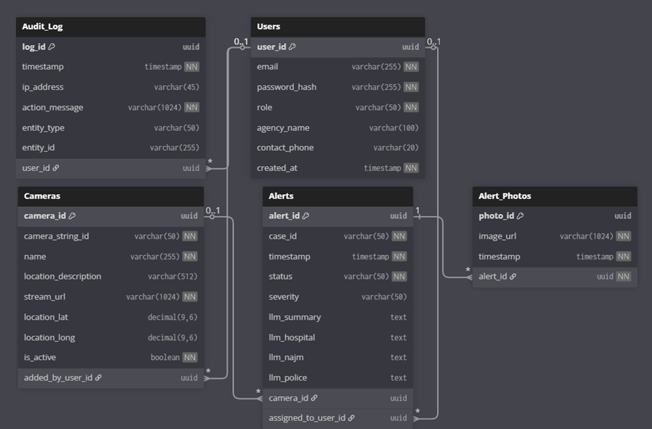
Figure 18: Physical Entity Relationship Diagram.

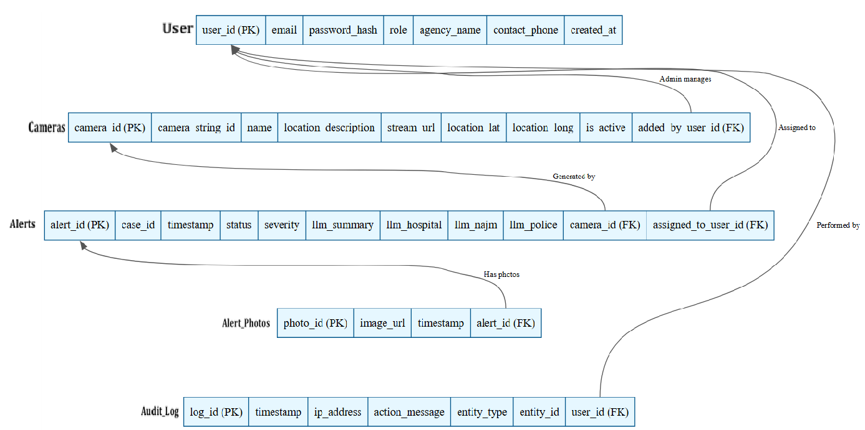
Figure 19: ERD Mapping Relational Schema.

5.7 Component Design
This section summarizes the internal logic of the main system components using simplified procedural pseudocode (PDL). Each component description includes its purpose and core algorithmic behavior. Only essential local data is shown where needed.

5.7.1 Detection Engine Component
Purpose: Processes video frames and detects accidents using the AI model.
Local Data:
THRESHOLD = minimum confidence required.

PDL:
function detectAccident(frame):
processed = preprocess(frame)
result = model.infer(processed)

if result.confidence >= THRESHOLD:
return result
else:
return null

5.7.2 Event Orchestrator Component
Purpose: Creates and updates accident events.
PDL:
function createEvent(detection):
event = new Event()
event.status = "detected"
save(event)
return event.id

function updateEventStatus(eventId, status):
event = load(eventId)
event.status = status
save(event)

5.7.3 Assignment Engine Component
Purpose: Selects the nearest available emergency units.
PDL:
function assignUnits(eventLocation):
units = getAvailableUnits()
for each unit in units:
unit.distance = computeDistance(unit.location, eventLocation)
return sortByDistance(units)

5.7.4 Notification Component
Purpose: Sends alerts for new or updated events.
PDL:
function sendAlert(eventId):
subscribers = getActiveUsers()
for each user in subscribers:
pushMessage(user, eventId)

5.7.5 Repository Layer (Data Access Component)
Purpose: Store and retrieve event data.
PDL:
function saveEvent(event):
SQL INSERT or UPDATE event

function getEvent(eventId):
return SQL SELECT event WHERE id = eventId

5.8 Detailed System Design
The Detailed System Design document provides a comprehensive overview of each component's role, the constraints that govern its operation, and its interaction with other components for the common goal of providing real-time accident detection and response, thereby conforming to the system's requirements and its architecture. Besides, it also lays out the application resources, interactions, and dataflows between services, processing logic at a high-level, and the interface/exports that each subsystem exposes for a maintainable, testable integration throughout the pipeline. Moreover, it contains detailed references for the design of subsystems and employs sequence and UML diagrams to make the distribution of responsibilities, state transitions, and messages across components clear, thus ensuring that developers and reviewers have a common, traceable understanding of behavior and dependencies.

5.8.1 Classification, Definition and Responsibilities
This section summarizes each component’s type, purpose, and key duties to ensure clear ownership and traceability from requirements to implementation across the accident detection and response pipeline.​

Component | Classification | Definition and Responsibility
Video Acquisition & Detection | Subsystem | It is receiving the live video feeds, preparing the images, running the AI models to identify potential accidents, and subsequently transmitting the detection events in a universally accepted format for further processing.
Emergency Event Management | Subsystem | It is performing the functions of the major accident event lifecycle controller by handling the succession of creating, checking, assigning, updating, and changing the event state.
Emergency Units Management | Subsystem | It continues to manage the lists of responders and their live availability, performs geospatial proximity queries, and helps in assigning the nearest suitable units to incidents.
Notification & Alerting | Subsystem | Through push channels and external connectors, it provides real-time updates to users which implies that alerts and status changes have been delivered in a trustworthy and auditable way.
UI Dashboard | Subsystem | It incorporates a secure web interface for monitoring incidents, displaying them on a map and in a list, and performing CRUD operations for system entities at the administrative level.
Data Management & Storage | Subsystem | It assures adherence to the ACID model for the core records and media artifacts by offering repository interfaces and indexing for fast reading and writing across services.
Cross-Cutting Services | Module set | Besides, it implements authentication, authorization, logging, and performance targets corresponding to the behavior off the subsystem, system-level requirements, and documentation traceability.
Table 30: Component Definitions and Responsibilities.

5.8.2 Composition
This section defines the constraints for each component, including its limitation, pre‑conditions, and post‑conditions, and summarizes how subcomponents compose the overall behavior.

Component | Limitation | Pre-condition | Post-condition
Video Acquisition & Detection | Requires stable network, 15–30 FPS and 720p+ streams, and sufficient GPU/CPU for inference. | Valid stream URL configured; model loaded; compute resources available. | Standardized detection event produced with timestamp, camera ID, confidence, and media reference.
Emergency Event Management | Must enforce valid lifecycle transitions and idempotent updates; relies on transactional storage. | Detection payload received; database connection available. | Event created/updated atomically; notifications queued; state persisted.
Emergency Units Management | Accurate geolocation and up-to-date availability required; depends on geospatial indexing. | Units registered with coordinates; spatial index initialized. | Ranked nearby available units returned; unit status updated if assigned.
Notification & Alerting | Real-time push required; resilience to channel outages; idempotent deliveries. | Active client session or configured external channel; valid event update. | Alerts delivered to recipients; delivery recorded in audit log.
UI Dashboard | Depends on backend APIs and push channels; require authenticated sessions. | User authenticated and authorized; services reachable. | Live data rendered and actions executed; UI synchronized with backend.
Data Management & Storage | ACID, 3NF schema, indexing, and retention policies must be enforced within capacity limits. | Migrations applied; storage healthy; access credentials valid. | Records persisted consistently; media stored; queries performant on indexes.
Table 31: Component Constraints and Conditions.

5.8.3 Uses/Interactions
Uses/Interactions describe each component's collaborations with other components, specifying which entities use it, what it uses (including side-effects on shared state like databases), and interaction methods such as message queues, REST APIs, or publish-subscribe topics, ensuring loose coupling across the modular pipeline.
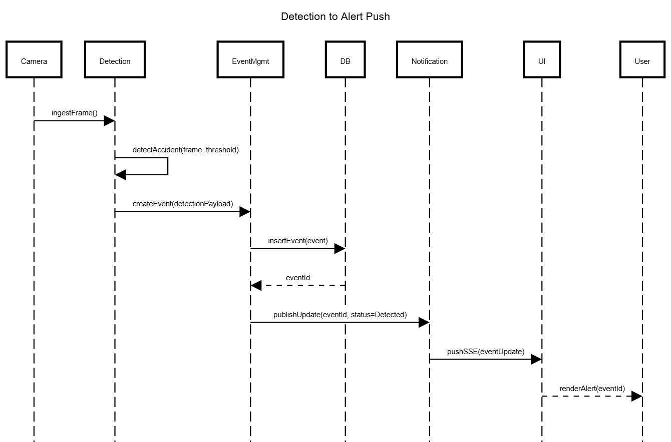
Figure 20: Sequence of Interactions Across Subsystems.

5.8.4 Resources
This section catalogs all external resources (hardware, software, network) required, managed, or impacted by each subsystem, including concurrency risks and mitigation strategies aligned with real-time constraints and shared state access.

Component | Required Resources | Managed Resources | Concurrency Risks | Mitigation
Video Acquisition & Detection | GPU/CPU, RTSP network streams (15-30 FPS), OpenCV/YOLO libraries | Frame buffers, keyframe storage | Buffer overflow on high FPS, multiple stream workers | Bounded queues with backpressure, single-writer per stream, exponential reconnect backoff SDS-Draft.docx
Emergency Event Management | PostgreSQL DB connection pool, message queue | Event records, audit logs | Concurrent event updates, unit assignment races | Row-level locking, optimistic concurrency (versioning), outbox pattern for notifications SDS-Draft.docx
Emergency Units Management | Geospatial indexes (PostGIS), Redis cache (optional) | Unit availability status | Multiple assignment queries updating same unit | Atomic CAS operations, availability leasing with TTL SDS-Draft.docx
Notification & Alerting | WebSocket/SSE connections, SMTP/SMS gateways | Notification audit records | Thundering herd on mass notifications | Debounced delivery, idempotent message IDs, topic partitioning SDS-Draft.docx
UI Dashboard | Browser session storage, HTTPS connections | N/A (stateless client) | Stale UI state during concurrent updates | Server-driven SSE pushes, cache-busting headers SDS-Draft.docx
Data Management & Storage | PostgreSQL server, S3-compatible object storage | All persistent data (ACID) | Deadlock on complex joins, write contention | Consistent lock ordering, short transactions (<100ms), connection pooling SDS-Draft.docx
Table 32: Resource Allocation and Concurrency Management.

5.8.5 Processing
This section describes how each subsystem performs its core responsibilities, specifying inputs, outputs, processing algorithms/steps, and constraints to ensure traceability from SRS requirements to implementation logic for the real-time accident detection pipeline.

5.8.5.1 Video Acquisition & Detection
Table 32 presents the description, inputs, outputs, and constraints of “Video Acquisition & Detection” component.
Attribute | Description
Inputs | RTSP/HLS stream URL, expected frame rate (15-30 FPS)
Outputs | Detection events containing {cameraId, timestamp, confidence, bounding box, keyframe reference}
Purpose | Continuously ingest video streams, preprocess frames, run AI inference to detect accidents in near real-time
Processing Steps | 1. Connect to video stream via RTSP connector.  2. Extract frames into bounded buffer.  3. Preprocess frames (e.g., resizing, normalization).  4. Run object detection model (YOLOv8), apply non-maximum suppression.  5. Filter detections by confidence threshold.  6. Capture keyframe when valid detection occurs.  7. Format and send detection payload to Event Management.
Constraints | Requires GPU/CPU availability for inference.  Must maintain end-to-end latency under 2 seconds.  Handle stream interruptions with reconnection and backoff logic.  As recovery Strategy in the event of stream failure, keep on trying connection before declare camera to be offline.
Table 33: Process Specification of Video Acquisition & Detection.

5.8.5.2 Emergency Event Management
Table 33 presents the description, inputs, outputs, and constraints of “Emergency Event Management” component.
Attribute | Description
Inputs | Detection payloads from Video Acquisition, unit assignment queries
Outputs | Event records including updated event status and assigned units; triggers notifications
Purpose | Manage accident event lifecycle: creation, deduplication, verification, assignment, updates, and persistence
Processing Steps | 1. Search existing events overlapping in time and space.  2. Create new or merge detections into existing events.  3. Optionally await manual verification.  4. Query available emergency units near the event.  5. Assign units and update event status.  6. Persist updates atomically.  7. Publish event updates for notification.
Constraints | Must ensure transactional integrity with optimistic locking.  Allow only valid state transitions.  Support idempotency to avoid duplicates.
Table 34: Process Specification of Emergency Event Management.

5.8.5.3 Emergency Units Management
Table 34 presents the description, inputs, outputs, and constraints of “Emergency Units Management” component.
Attribute | Description
Inputs | Event location (latitude/longitude), unit type filters
Outputs | Ranked list of available emergency units with distances
Purpose | Maintain emergency responder directories, availability status, and provide proximity queries for assignments
Processing Steps | 1. Query geospatial index to find units within radius.  2. Filter units by type and availability.  3. Sort by geographic distance.  4. Return top candidates.  5. Update unit availability atomically on assignment.
Constraints | Accurate GPS data required.  Geospatial index must be up to date.  Use atomic operations to prevent race conditions on availability.
Table 35: Process Specification of Emergency Units Management.

5.8.5.4 Notification & Alerting
Table 35 presents the description, inputs, outputs, and constraints of “Notification & Alerting” component.
Attribute | Description
Inputs | Event update messages {eventId, status, summary}
Outputs | Delivered notifications via WebSocket/SSE and external channels; audit logs
Purpose | Route event updates reliably to subscribed clients and external notification channels
Processing Steps | 1. Determine recipients based on roles and locations.  2. Enqueue messages for delivery.  3. Send notifications via WebSocket/SSE.  4. Retry on failure with backoff.  5. Log delivery results for auditing.
Constraints | Ensure idempotent delivery for consistency.  Handle outages gracefully.  Maintain low latency (<1 second).
Table 36: Process Specification of Notification & Alerting.

5.8.5.5 UI Dashboard
Table 36 presents the description, inputs, outputs, and constraints of “UI Dashboard” component.
Attribute | Description
Inputs | API responses for incidents and units; server-sent events (SSE) for real-time updates
Outputs | Rendered UI views including maps, incident lists, and admin management pages
Purpose | Provide an interactive, responsive interface for monitoring incidents and managing system data
Processing Steps | 1. Authenticate users and establish SSE connection.  2. Fetch initial state via REST APIs.  3. Render map and lists.  4. Handle user actions with optimistic updates.  5. Sync UI state based on server events.
Constraints | Secure authentication and role-based access.  Minimize UI latency and handle conflicting updates smoothly.  As security Strategy Session timeout after 15 minutes of inactivity; force re-login.
Table 37: Process Specification of UI Dashboard.

5.8.5.6 Data Management & Storage
Table 37 presents the description, inputs, outputs, and constraints of “Data Management & Storage” component.
Attribute | Description
Inputs | CRUD requests from all subsystems; media files (keyframes, clips)
Outputs | Confirmation of persisted data; query results
Purpose | Provide reliable ACID-compliant storage and efficient query capabilities for all system data
Processing Steps | 1. Validate data schema and constraints.  2. Perform indexed query or transaction.  3. Upload media to object store.  4. Log all writes in audit logs.  5. Return operation results or error messages.
Constraints | Maintain ACID compliance.  Enforce data normalization.  Ensure sub-100ms transaction latencies.
Table 38: Process Specification of Data Management & Storage.

5.8.6 Interface/Exports
This section summarizes the main services and interfaces exposed by each subsystem so that developers can understand how to use them and verify that the system functions as expected. It focuses on the purpose and role of each interface rather than low-level implementation details, and it should be read together with the SRS external interface requirements and the detailed subsystem design diagrams.
Subsystem | Interfaces / Services | Purpose
Video Acquisition & Detection | Internal endpoint for detection results (e.g., POST /events/detections), internal message topic for detection events | Provides a standardized accident detection payload (camera identifier, timestamp, confidence, region of interest, and media reference) to the Emergency Event Management subsystem after processing live camera streams.
Emergency Event Management | REST APIs for creating and updating events (e.g., /events, /events/{id}, /events/{id}/status, /events/{id}/assign), internal event-update topic | Acts as the main access point for creating accident events, updating their lifecycle status, assigning units, and broadcasting event changes to other subsystems such as Notification and UI Dashboard.
Emergency Units Management | REST APIs for managing and querying units (e.g., /units, /units/{id}, /units/nearby) | Exposes CRUD operations for hospitals, police, and fire units, and provides a proximity search service used by the Event Management subsystem when selecting suitable responders for an incident.
Notification & Alerting | WebSocket or Server-Sent Events endpoint for real-time updates (e.g., /ws/updates), internal notification trigger endpoint (e.g., POST /notify/{eventId}) | Delivers real-time alerts and status changes to connected dashboards and, when configured, to external channels such as SMS or email, while recording notification attempts in the audit log.
UI Dashboard | Web client that consumes backend REST APIs and subscribes to real-time updates | Provides administrator and responder user interfaces for all core functions, including camera management, user management, viewing and verifying incidents, and monitoring assigned units and alerts.
Data Management & Storage | Database schema and repository layer accessed via ORM/DAO classes | Offers persistent storage for users, cameras, alerts, units, notification logs, and audit entries, serving all subsystems through well-defined data access methods rather than direct SQL in business logic.
Table 39: System Interface Specifications.

5.8.7 Detailed Subsystem Design
This section presents the detailed design of each major subsystem in the Real‑Time Accident Detection and Emergency Alert System, including their internal structure, control flow, and data usage. It refines the high‑level architecture by showing how the subsystems are decomposed into subcomponents and how these subcomponents collaborate to implement the functional requirements defined in the SRS.​
For each subsystem (Video Acquisition & Detection, Emergency Event Management, Emergency Units Management, Notification & Alerting, UI Dashboard, and Data Management & Storage), the detailed design is documented using a combination of class/Component diagrams, sequence diagrams, and data models that illustrate:​
- Internal subcomponents and their responsibilities
- Main control and data flows inside the subsystem
- Key algorithms or processing steps for core functions (e.g., detection, event lifecycle, unit selection, notification routing)
Where appropriate, these details are maintained directly with the source code (e.g., API definitions, repository classes, and model implementations). The SDS therefore references those artifacts and the diagrams in the System Architecture and Data Design sections instead of duplicating low‑level declarations, ensuring the design remains consistent and maintainable as the implementation evolves.​

5.9 Other Design Features

This section captures additional design aspects that are not fully covered in the previous sections but still influence how the system behaves, evolves, or integrates into its environment. In this project, the Real‑Time Accident Detection and Emergency Alert System adopts several cross‑cutting design choices, including the use of an event‑driven, modular architecture, separation of AI inference from user‑facing components, and centralized auditing of all critical actions for accountability and troubleshooting.​

The design also emphasizes extensibility by allowing future integration of new detection models, external notification channels, and additional emergency agencies without major changes to existing subsystems. Configuration is externalized where possible (e.g., camera endpoints, model thresholds, and notification rules), and non‑functional concerns such as logging, authentication, and role‑based access control are implemented as shared services to reduce duplication and keep business logic focused on accident detection and response workflows.

5.10 Requirements Traceability Matrix

This section links each major functional requirement defined in the SRS to the subsystems and design elements that implement it in the SDS. The full, detailed matrix is maintained in the “Requirements Traceability Matrix” subsection of the SDS and references the SRS Section 4.3 for requirement definitions and SDS Section 5.8 for detailed component design.

Associated ID in SRS | Technical Assumption | Functional Requirement (summary) | User | Associated ID in SDS | System Component
SRS (4.2.2 Product functions – Real-Time Video Monitoring) | Stable RTSP/HLS camera streams; GPU/CPU able to process 15–30 FPS at 720p+ | System shall continuously receive and monitor live video streams from surveillance cameras. | Admin, Responder | SDS (5.5.3 Subsystem Architecture – Video Acquisition & Detection; 5.8.5.1 Process Specification of Video Acquisition Detection) | Video Acquisition & Detection Subsystem.
SRS (4.2.2 – Accident Detection Using Deep Learning) | Trained YOLOv8/CNN models; annotated datasets available. | System shall automatically detect car accidents in the incoming video frames using deep learning. | Admin, Responder | SDS (5.7.1 Detection Engine Component; 5.8.5.1) | Detection Engine Component within Video Acquisition & Detection.
SRS (4.2.2 – Accident Classification and Severity Assessment) | Events stored with time and location; severity rules/ML model defined. | System shall classify each confirmed accident by severity (e.g., minor, moderate, major). | Admin, Responder | SDS (5.7.2 Event Orchestrator; 5.8.5.2 Emergency Event Management; Alerts.severity in 5.6.2 Data Dictionary) | Emergency Event Management / Event Orchestrator.
SRS (4.2.2 – Automated Alert and Notification System) | Network connectivity to dashboard and external channels. | System shall generate and send alerts containing time, location, severity, and camera reference. | Admin, Responder | SDS (5.7.4 Notification Component; 5.8.5.4; System Interface Specifications in 5.4.5 & 5.8.6) | Notification & Alerting Subsystem.
SRS (4.2.2 – System Management and Monitoring Dashboard; UI Tables 21–23) | Role-based web access via HTTPS. | System shall provide an admin dashboard for managing cameras, users, and viewing system status. | Admin | SDS (5.4.3 Screen Images, Tables 20–23; 5.4.4 Screen Objects and Actions; 5.8.5.5 UI Dashboard) | UI Dashboard – Admin views.
SRS (4.2.2 – Emergency Units Management) | Units registered with coordinates and availability. | System shall manage emergency units (CRUD) and expose them for assignment. | Admin | SDS (5.5.3 Emergency Units Management; 5.7.3 Assignment Engine; 5.8.5.3) | Emergency Units Management Subsystem.
SRS (4.2.2 – Nearest Units Selection) | Geospatial index and event location available. | System shall provide the nearest available units for a given incident location. | Admin, Responder | SDS (5.7.3 Assignment Engine; 5.8.5.3 Process Specification of Emergency Units Management) | Assignment Engine / Units Proximity Service.
SRS (4.3.1.1 – Login Interface, Table 20) | Auth service and user table configured. | System shall authenticate admins and responders using email and password. | Admin, Responder | SDS (5.4.3 Figures 1–2; 5.4.4 Screen Objects and Actions) | Login & Reset Password interfaces backed by Auth API.
SRS (4.3.1.1 – Responder Dashboard Interface, Table 24–26) | Active WebSocket/SSE connection. | System shall display an active incidents map and list for responders, with live updates. | Responder | SDS (5.4.3 Figures 7–9; 5.4.4; 5.8.5.5 UI Dashboard) | UI Dashboard – Responder views with real-time alert feed.
SRS (non-functional – audit / logging in SRS 2.2 & 3) | Central relational DB and audit schema deployed. | System shall log key user and system actions for auditing and troubleshooting. | Admin | SDS (5.6.2 Data Dictionary – AuditLog; 5.6.3 ERD; 5.8.4 Resources) | Data Management & Storage + logging in Event Management and Notification.
SRS (4.3.1.1 – Camera Management Interface, Table 22) | Camera records stored in DB with stream URLs; RTSP/HLS supported.​ | System shall allow admins to add, edit, delete, and view configured camera streams. | Admin | SDS (5.4.3 Figure 4; 5.4.4 Screen Objects and Actions – Camera Mgt.; 5.5.3 Video Acquisition Module) | Camera Management UI + Video Stream Ingestion interface. ​
SRS (4.3.1.1 – User Management Interface, Table 23) | User and agency tables exist; RBAC model defined.​ | System shall allow admins to manage responder agency users (create, update, delete). | Admin | SDS (5.4.3 Figure 5; 5.4.4 – User Mgt.; 5.5.3 UI Dashboard Module) | User Management UI + backend User Management API. ​
SRS (4.3.1.1 – System Audit Log Interface) | AuditLog table and logging middleware enabled.​ | System shall provide an audit log screen showing key system activities with filters and export. | Admin | SDS (5.4.3 Figure 6; 5.4.4 – Audit Log; 5.6.2 AuditLog entity) | System Audit Log UI + Data Management & Storage. ​
SRS (4.3.1.1 – Incident Reports & Details, Tables 24–26) | Incidents persisted with IDs, timestamps, and status.​ | System shall show responders a list of past and active incidents and detailed accident information. | Responder | SDS (5.4.3 Figures 8–9; 5.4.4 – Incident Reports, Accident Details; 5.8.5.5 UI Dashboard) | Incident Reports & Accident Details views backed by Event Management. ​
SRS (Overall description / non‑functional – Authentication & Roles) | Secure HTTPS deployment, hashed passwords, roles Admin/Responder.​ | System shall restrict access via authenticated login and enforce role‑based permissions. | Admin, Responder | SDS (5.3.2 General Constraints – Security & Privacy; 5.4.1 Overview of UI; 5.8.4 Resources) | Cross‑cutting security (Auth, RBAC, Audit) integrated into all subsystems. ​
SRS (Overall description – Real‑time Processing) | Hardware and network sufficient to target < 2 s end‑to‑end latency.​ | System shall process video streams and generate alerts in near real time (target < 2 seconds). | System-level | SDS (5.3.2 General Constraints – Performance & Latency; 5.8.5 Process tables 32–37) | Pipeline design across Video Acquisition, Event Mgmt, Notification, UI, Data. ​
SRS (Overall description – Reliability & Recovery) | Reconnect and retry strategies implemented; message delivery tracking available.​ | System shall handle stream drops and transient failures via reconnection and retry mechanisms. | System-level | SDS (5.3.2 General Constraints – Network & Storage; 5.8.4 Resources; 5.8.5 Processing for affected subsystems) | Stream Connector, Notification & Alerting, Repository Layer. ​
SRS (Overall description – Data Persistence) | Relational DB and object storage deployed and reachable.​ | System shall persist accident events, media, and related entities in a consistent, normalized schema. | System-level | SDS (5.6.1 Data Description; 5.6.2 Data Dictionary; 5.6.3 Database Description) | Data Management & Storage (ERD, tables Alerts, AlertPhotos, Users, Cameras, AuditLog). ​
Table 40: Requirements Traceability Matrix Linking SRS Functional Requirements to SDS System Components

References
- Karim et al., “Visual Detection of Traffic Incidents through Automatic Scene Understanding,” 2024.
- Z. Chen et al., “Traffic Accident Data Generation Based on Improved Generative Adversarial Networks,” Sensors, 2021.
- M. S. Arefin et al., “Real-time rapid accident detection for optimizing road safety in Bangladesh,” Heliyon, 2025.
- M. M. Ahmed, A. Al-Fuqaha, and M. Al-Ajlan, “A real-time deep learning-based framework for traffic accident detection and alerting using CCTV feeds,” Big Data and Cognitive Computing, vol. 7, no. 2, p. 22, 2023.
- S. Ayesha, A. Aslam, M. H. Zaheer, and M. B. Khan, “CIRS: A Multi-Agent Machine Learning Framework for Real-Time Accident Detection and Emergency Response,” Sensors, 2025.
- S. M. Elhag, G. H. Shaheen, and F. H. Alahmadi, "Accident Response Time Enhancement Using Drones: A Case Study in Najm for Insurance Services," International Journal of Information Technology and Computer Science, vol. 15, no. 6, pp. 1–14, 2023.
- Z. Xi, X. Liu, Y. Liu, Y. Cai, and Y. Zheng, "Integrating Generative Adversarial Networks and Convolutional Neural Networks for Enhanced Traffic Accidents Detection and Analysis," IEEE Transactions on Intelligent Transportation Systems, 2025.
- M. Ragab, F. Kateb, M. W. Al-Rabia et al., "A Machine Learning Approach for Monitoring and Classifying Healthcare Data—A Case of Emergency Department of KSA Hospitals," International Journal of Environmental Research and Public Health, vol. 20, no. 4794, 2023.
- H. Ghahremannezhad, H. Shi, and C. Liu, “Real-Time Accident Detection in Traffic Surveillance Using Deep Learning,” Conference Paper, 2022.
- Y. Zhang and Y. Sung, “Traffic Accident Detection Method Using Trajectory Tracking and Influence Maps,” Mathematics, vol. 11, no. 7, p. 1743, Apr. 2023.
- D. T. Mane et al., “Real-time vehicle accident recognition from traffic video surveillance using YOLOv8 and OpenCV,” International Journal on Recent and Innovation Trends in Computing and Communication, vol. 11, no. 5s, pp. 250–258, 2023.
- Y. Zhang and Y. Sung, “Traffic accident detection using background subtraction and CNN encoder–transformer decoder in video frames,” Mathematics, vol. 11, no. 13, p. 2884, 2023.
- J. A. Ruby Florence and G. Kirubasri, “Accident detection system using deep learning,” in Proc. Int. Conf. on Computational Intelligence in Data Science, 2022, pp. 301–310.
- K. Pawar and V. Attar, “Deep learning based detection and localization of road accidents from traffic surveillance videos,” ICT Express, vol. 8, no. 3, pp. 379–387, 2022.
- Y. Xu et al., “TAD: A large-scale benchmark for traffic accidents detection from video surveillance,” IEEE Access, 2024.
- V. Adewopo et al., "Big Data and Deep Learning in Smart Cities: A Comprehensive Dataset for AI-Driven Traffic Accident Detection and Computer Vision Systems," arXiv preprint arXiv:2401.03587, 2024.
- S. Bakheet and A. Al-Hamadi, "A deep neural framework for real-time vehicular accident detection based on motion temporal templates," Heliyon, vol. 8, no. 11, p. e11397, 2022.
- H. Liao et al., "CRASH: Crash Recognition and Anticipation System Harnessing with Context-Aware and Temporal Focus Attentions," in Proc. 32nd ACM Int. Conf. on Multimedia, 2024.
- N. Behboudi, S. Moosavi, and R. Ramnath, "Recent Advances in Traffic Accident Analysis and Prediction: A Comprehensive Review of Machine Learning Techniques," arXiv preprint arXiv:2406.13968, 2024.
- R. Zhang, B. Wang, J. Zhang et al., "When language and vision meet road safety: leveraging multimodal large language models for video-based traffic accident analysis," arXiv preprint arXiv:2501.10604, 2025.
- J. Fang, J. Qiao, J. Xue, and Z. Li, “Vision-Based Traffic Accident Detection and Anticipation: A Survey,” arXiv preprint arXiv:2308.15985, 2023.
- N. M. L. et al., “An Automated System for Accident Detection Using OpenCV,” International Journal for Research in Applied Science & Engineering Technology, vol. 13, no. 4, 2025.
- S. Akter, I. F. Shihab, and A. Sharma, “Large Language Models for Crash Detection in Video: A Survey of Methods, Datasets, and Challenges,” arXiv preprint arXiv:2507.02074, 2025.
- Omari Alaoui et al., “Advancing Emergency Vehicle Systems with Deep Learning: A Comprehensive Review of Computer Vision Techniques,” Intelligent Systems with Applications, vol. 28, 200574, 2025.
- X. Wu et al., “Big Data and Deep Learning in Smart Cities: A Comprehensive Dataset for AI-Driven Traffic Accident Detection,” 2024.

